Rwanda GAFSP Proposal

Sustainable Agricultural Intensification for Improved  
Livelihoods, Food Security and Nutrition Project (SAIP)



Ministry of Agriculture and Animal Resources  
MINAGRI

January 2017

Abbreviations/Acronyms

|  |  |  |  |
| --- | --- | --- | --- |
| AgPER | Agricultural Public Expenditure | NAEB | National Agricultural Export |
|  | Review |  | Development Board |
| AfDB | African Development Bank | NAIP | National Agricultural Investment Plan |
| ASIP | Agricultural Sector Development Plan | NAP | National Agricultural Policy |
| CAADP | Comprehensive African Agricultural | NGO | Non-Governmental Organization |
|  | Development Programme | NISR | National Institute of Statistics |
| CIDA | Canadian International Development | O&M | Operation and maintenance |
|  | Agency | PASP | Post-harvest and Agribusiness |
| DHS | Demographic Health Survey |  | Support Project |
| EAX | East African Exchange | PDO | Project Development Objective |
| EICV4 | Integrated Household Consumption | PfR | Project for Results |
|  | Survey | PPP | Public Private Partnership |
| FAO | Food and Agriculture Organization of | PRICE | Project for Rural Income Through |
|  | the United Nations |  | Exports Promotion |
| FFS | Farmer Field School | PSTA | Strategic Plan for Transformation of |
| GAFSP | Global Agriculture and Food Security |  | Agriculture |
|  | Program | RAB | Rwanda Agriculture Board |
| GAP | Good Agricultural Practices | RALICS | Rwanda Agriculture and Livestock |
| GDP | Gross Domestic Product |  | Inspection and Certification Services |
| GFI | Government Funded Irrigation | RCSP | Rural Community Support Project |
| GoR | Government of Rwanda | RDDP | Rwanda Diary Development Project |
| ICT | Information Technology |  | Refugee Affairs |
| ICT4RAg | Information and Communication | RF | Results Framework |
|  | Technology for Rwandan Agriculture | RGCC | Rwanda Grain and Cereals |
| IDA | International Development Agency |  | Cooperation |
| IFAD | International Fund for Agriculture | RSSP | Rural Sector Support Project |
|  | Development | RYAF | Rwanda Youth in Agribusiness Forum |
| IPM | Integrated Pest Management | SACCO | Savings and Credit Cooperative |
| KCB | Kenya Commercial Bank | SAIP | Sustainable Agricultural |
| LISP | Livestock Infrastructure Support |  | Intensification for Improved |
|  | Programme |  | Livelihoods, Food Security and |
| LWH | Land Husbandry, Water Harvesting |  | Nutrition |
|  | and Hillside Irrigation Project | SDG | Sustainable Development Goal |
| M&E | Monitoring and Evaluation | SHG | Self-help Group |
| MIC | Middle Income Country | SP | Strategic Programme |
| MIDIMAR | Ministry of Disaster Management and | SPIU | Single Project Implementation Unit |
| MIGEPROF | Ministry of Gender and Family | SSIT | Small-Scale Irrigation Technology |
| MINAGRI | Ministry of Agriculture and Animal | UN | United Nations |
|  | Resources | USAID | United States Agency for International |
| MINALOC | Ministry of Local Government |  | Development |
| MINEDUC | Ministry of Education | USD | United States Dollars |
| MINISANTE | Ministry of Health | WB | World Bank |
| MTR | Mid-Term Review | WUA | Water Users Association |
| MYICT | Ministry of Youth and ICT |  |  |

TABLE OF CONTENTS

**Abbreviations/Acronyms 2**

**TABLE OF CONTENTS 3**

1. **Summary of Overall Agriculture, Food security Strategy and Investment Plan 4**
   1. Overall Sector Strategy and Investment Plan, and Past Performance 4
   2. Key Elements of the Policy Environment 5
   3. Government Commitment to Agriculture and Food Security 6
   4. Processes for Formulating, Updating and Implementing PSTA III 7
   5. Implementation capacity and arrangements 8
   6. Performance of past GAFSP grant allocation 8
2. **Specific Proposal for GAFSP financing 10**
   1. Justification for the overall approach 10
   2. Specific objectives, expected results and target beneficiaries 12
   3. Activities to be financed 15
   4. Implementation arrangements 22
   5. Amount of financing requested and time-frame for implementation 22
   6. Preferred supervising entities 23
   7. Post project sustainability and exist strategies 23
   8. Risks and risk management 24
   9. Consultations with local stakeholders and development partners 25
   10. Plan for detailed preparation 26
3. **Detailed sub-sectoral policy framework 27**
4. **Implementation progress of LWH/previous GAFSP financing 28**
5. **Recent major investment projects under PSTA III 30**
6. **Detailed cost table 31**
7. **Consultations: list of people met/consulted 33**
8. Summary of Overall Agriculture, Food security Strategy and Investment Plan
   1. Overall Sector Strategy and Investment Plan, and Past Performance

Rwanda has shown significant progress towards its desired development outcomes in the past decade. Poverty has reduced from 45% in 2011 to 39% in 2014; extreme poverty has reduced from 24% to 16%; and rural poverty decreased from 62% to 49% over the past 5 years. Agriculture contributed to about 60% of the total poverty reduction.[1] Increased agricultural production has also contributed significantly to improving the nutritional status of people, in combination with health and sanitation interventions. By 2014/15[2], wasting (acute malnutrition) was registered at 2% while the underweight was at 9%. Though there has been a reduction in the stunting rate from 44 % in 2010 to 38% in 2014, the rate is still high and unacceptable.

The agricultural sector plays a pivotal role in Rwanda’s overall economy, as reflected in the following key indicators[3]: it contributes 33% of the GDP (2015); provides employment to about 68% of the labor force; generates 90% of the national food requirements; and 70% of the country’s export revenues. There is real agro-processing potential with the private sector playing an increasingly important role in market development. The agriculture sector is also instrumental in achieving or influencing the achievement of many of the Sustainable Development Goals (SDGs) especially with respect to: SDG 1 (end extreme poverty); SDG 2 (zero hunger, improved nutrition and sustainable agriculture); SDG 8 (decent work and economic growth); SDG 13 (climate action); SDG 15 (terrestrial ecosystems, forests and land) and agriculture is expected to play a key role in moving Rwanda towards Middle Income Country (MIC) status.

Vision 2020 is the Government of Rwanda’s multi-sectoral long-term development vision and policy for promoting socio­economic transformation; it articulates the key priorities for the country’s development by the year 2020. The vision is operationalized through a series of five-year national and sectoral plans. Vision 2020, together with the five-year Economic Development and Poverty Reduction Strategy II (EDPRS II)[4], delineates agriculture as a key sector and a major engine to achieve the country’s inclusive growth and poverty reduction targets. The Ministry of Agriculture and Animal Resources (MINAGRI) is currently implementing its Strategic Plan for the Transformation of Agriculture (PSTA) - Phase III[5]. The PSTA III is strongly aligned and harmonized with Vision 2020 and EDPRS II. PSTA III forms part of Rwanda’s Comprehensive African Agriculture Development Programme (CAADP) Phase 2, and is the guiding document for the second Agricultural Sector Investment Program (ASIP II), also known as a National Agricultural Investment Plan II (NAIP II).

The primary goals of the PSTA III are: (i) transformation of Rwandan agriculture from a subsistence sector to a market- oriented, value-creating sector, and (ii) rapid growth in production and commercialization in order to increase rural incomes and reduce poverty. The PSTA III seeks to achieve four transformational results of: (i) achieving food security through economic growth; (ii) farmers to be active market players with new skills; (iii) government to be a facilitator for private sector investment; and (iv) Rwanda to be an exporter. PSTA III is operationalized through 4 strategic programmes (SPs) presented in Table 1; which also reflects annual investment needs. The investment gap over the 5 year period was estimated at US$ 278,962,000. Special attention is given to the impacts of climate change especially recurrent increased drought and flash flood events, increased average temperatures and changes in annual and seasonal rainfall. Climate related impacts are likely to have disproportionately strong effects on the poor, as such vulnerable groups have fewer resources to adapt to climatic change.

A Results Framework (RF), developed in 2014, underpinned by an explicit results chain of identified “drivers” of inclusive agricultural growth is in place. MINAGRI uses this enhanced RF as a tool to support its annual planning and budgetary processes and to help operationalize an enhanced M&E system, based on “core” SMART result indicators.

Table 1: ASIP Public Sector Costs by Program (US$ Thousands)

|  |  |  |  |  |  |  |  |
| --- | --- | --- | --- | --- | --- | --- | --- |
|  | **2013/14** | **2014/15** | **2015/16** | **2016/17** | **2017/18** | **Total** | **%** |
| **SP1**: Agriculture/Animal Resources Intensification | 133 326 | 141 426 | 131 122 | 121 434 | 112 649 | 639 957 | 52.74 |
| **SP2**: Research and Technology Transfer | 12 157 | 15 647 | 18 060 | 19 701 | 20 481 | 86 046 | 7.09 |
| **SP3**: Value Chain Development / Private Sector Investment | 65 075 | 7 046 | 74 915 | 84 099 | 88 360 | 382 495 | 31.52 |
| **SP4**: Institutional Development / Cross-cutting Issues | 18 831 | 20 186 | 21 079 | 21 980 | 22 941 | 105 018 | 8.65 |
| **Total costs** | **229 389** | **247 305** | **245 175** | **247 215** | **244 433** | **1 213 517** | **100** |

*Source: ASIP II*

The CAADP and Country Systems Assessments “The Case of Rwanda” (commissioned by NEPAD Agency, 2015) cites Rwanda as one of the better performing countries in implementing the CAADP agenda. PSTA III is directly and well aligned with the objectives and components of Vision 2020, the EDPRS II, and with the CAADP. PSTA III has achieved a significant measure of success particularly on the institutional front and has invested in improving the enabling policy environment. Land treated with soil conservation technologies reached 1,007,575 ha in June 2016 representing 83% of the total target to be treated from a baseline of 848,538 ha in 2014; and area developed for irrigation reached 45,099 ha in June 2016 representing 79% of the total PSTA III target from a baseline of 28,796 ha in 2014. The Twigire-Muhinzi extension model has been successfully launched as a home-grown adaptation of the Farmer Field School (FFS) approach to ensure that farmers have access to advisory services, appropriate agricultural technologies and knowledge. It has created ideal conditions for technology transfer and exchange of information between producers, farmer organizations and different partners. However, a number of key output targets are not likely to be achieved by 2017/18 due mainly to underfunding. Gaps in funding includes the area of physical infrastructure works (terracing, irrigation etc.) which undermines production targets of food crops and export crops, especially fruits and vegetables. Limited complementary investment by individual farmers and the private sector also reduces achievements.

* 1. Key Elements of the Policy Environment

Rwanda has successfully laid down an institutional policy environment covering a range of sub-sectoral issues such as food crops; export crops; fertilizer; seed production; livestock and mechanization; as well as regulations on phyto-sanitary issues (plant health) and agro-chemicals. The sub-sectoral policies are largely aligned and complementary to each other. A comprehensive overview of current and foreseen policies relevant to the agricultural sector and food security is provided in Annex 1. These policies, in their content and implementation, have been improving over the years in a steady and positive manner and have endeavored to create an enabling environment for improved agricultural performance, including enhanced productivity and profitability to drive and accelerate inclusive agricultural growth and reduced poverty.

MINAGRI is currently updating the National Agricultural Policy, which was initially approved in 2004 to mainstream emerging issues of climate change, nutrition, ICT, and youth employment. MINAGRI has developed a gender mainstreaming strategy promoting gender equality in agricultural development and food and nutrition security. In addition, the Ministry has worked with the Ministry of Youth and ICT to establish a countrywide Youth Forum in agribusiness with the objective of facilitating youth’s role in the modernization of the sector. The Government has also formulated, approved and implemented several other specific thematic agricultural policies and strategies including on irrigation, agriculture finance and agribusiness.

* 1. **Government Commitment to Agriculture and Food Security**

The level and depth of Government’s commitment to enhancing the performance and impacts of the agricultural sector is reflected in the significant efforts undertaken to date as outlined above, especially related to improving the policy and enabling environment, as well as the institutional set-up. The public budget allocation to agriculture reflects the country’s commitment to this sector. Over the period 2009/10 to 2014/2015, total public spending, including by Development Partners, on agriculture as per total national budget has fluctuated around 10% per year as detailed in Table 2.

Table 2: Public spending in agriculture as per total national budget

|  |  |  |  |  |  |  |
| --- | --- | --- | --- | --- | --- | --- |
| **Year** | 2009/10 | 2010/11 | 2011/12 | 2012/13 | 2013/14 | 2014/15 |
| **%** | 9.08 | 9.25 | 11.42 | 8.61 | 8.69 | 10.01 |

*Source: Annual Analysis of Rwanda’s Agricultural Budget Expenditure 2015-16, The Institute of Policy Analysis and Research (2015)*

The PSTA III budget allocations (Table 3 below) across the four Strategic Programmes and the 24 sub-programme categories amount to a total of RWF 1,090 billion. Of this total, about RWF 648 billion (60%) corresponds to the public sector and RWF 441 billion (40 %) was to be from the private sector. When assessing the PSTA III budget allocations, a skewed picture emerges with about 98.5 % of the expenditures being allocated to two Strategic Programmes; SP1 - Agriculture and Animal Resource Intensification (75.2%) and SP3 - Value Chain Development and Private Sector Investment (23.3%). This reflects the commitment of the Government to a transformation of the agricultural sector through an intensification of agriculture and livestock production systems supported by value chain development aimed at increasing the marketing of outputs both within the country and for export. In line with Rwanda’s decentralization policies, increasing shares of expenditures are being allocated/earmarked to the Districts. The implementation of sub-programs through the Districts, underpinned by the performance contracts (IMIHIGO), has been found to be a sound approach to achieve and sustain results.

Table 3: PSTA III Summary and revised cost tables

|  |  |  |  |
| --- | --- | --- | --- |
| **Programs** | **Cost** | | **% of total** |
| **FRW (billion**) | **USD (million)** |
| **P.1 Agriculture and Animal Resource Intensification** | 80865 | 118,483.5 | **75.2** |
| **P.2 Research & Technology Transfer, Advisory Services and Professionalization of Farmers** | 12.84 | 18.81 | **1.2** |
| **P.3 Value Chain Development and Private Sector Investment** | 254.44 | 372.81 | **23.3** |
| **P.4. Institutional Development and Agricultural Cross Cutting Issues** | 14.23 | 20.85 | **1.3** |
| **TOTAL PSTA III** | **1,090.16** | **1,597.3** | **100** |
| **PUBLIC SECTOR investments** | 648.90 | 950.77 | 60% |
| **PRIVATE SECTOR investments** | 441.26 | 646.53 | 40% |
| Note: Total ASIP estimates are 10 % higher than PSTA III numbers |  |  |  |

*Source:PSTA III (May 2013)*

Food and nutrition have become a foundational issue of Rwanda’s plans for economic development and poverty reduction. The National Food and Nutrition Policy (NFNP) established in January 2014 outlines actions needed to sustain this position and innovative multi-sector and sector-specific strategies that will help assure that in Rwanda food and nutritional improvement becomes and remains everyone’s commitment. Hence, for a clear linkage and synergy between household food security, optimal nutrition, and social protection, the Government has put in place a multisector approach. Policy ownership, planning and implementation are the responsibilities of MINALOC, MINISANTE and MINAGRI while other social cluster Ministries including MINEDUC, MIGEPROF and MIDIMAR also have essential implementation responsibilities.

A separate Agricultural Public Expenditure Review (AgPER) on nutrition and household vulnerability carried out in 2015­2016 indicates that there is indeed an increasing commitment towards nutrition related sub-programmes (with programmed expenditures having increased by 105% since 2011/12)[6].

* 1. Processes for Formulating, Updating and Implementing PSTA III

Following an evaluation of the PSTA I and II, PSTA III was amended to align with Government’s increasing emphasis on food security and the recognition of the central role of agriculture in poverty reduction and growth as laid out in the EDPRS II. The PSTA III was developed in a participatory manner, and broad stakeholder involvement in implementation keeps increasing. For preparation of the PSTA III, several consultation meetings were held in 2014 specifically with the private sector; various ASIP review meetings took place as well as regular Sector Working Groups meetings. The stakeholders involved in preparation and implementation of the PSTA III include Government institutions, NGOs, and private sector, especially farmers and farmer-based organizations.

The budgetary planning process used by MINAGRI is a key entry point for this participation. It includes bi-annual joint sector reviews (backward and forward looking); reporting on the performance contracts; regular meetings of the SWAp Committee (MINAGRI and Development Partners) and the Agriculture Sector Working Group (multi-stakeholder); and Joint Action delivery committees and development forums at decentralized level. The development of a comprehensive Results Framework has also allowed for more inclusive stakeholder participation accountability, and participatory M&E system. Private sector participation, especially through cooperatives, farmer organizations and PPPs, is slowly increasing following the value chain approach.

* 1. Implementation capacity and arrangements

To improve capacities and performance, a successful restructuring of MINAGRI was undertaken almost from the outset of the PSTA III. The implementation of the PSTA III was also positively affected by increasing competence of District Administrations. The performance contract system followed by Rwanda was a positive contributor to achieving the agreed targets (individual and joint IMIHIGO targets), as it supported efficiency and effectiveness of resource utilization.

The GoR through the Ministry of Agriculture and Animal Resources has established the Single Project Implementation Unit (SPIU) approach as a simple and effective way to implement all projects in the sector. The previous GAFSP financing was well managed and implemented under the SPIU which is managing the World Bank funds. This SPIU has an experienced and strong team which has enabled the Ministry to obtain rapid and satisfying results. The weight of implementation of agriculture project activities is increasingly found at the down-stream level of the Districts, where capacity is increasing thanks to investment in capacity development at all levels.

* 1. Performance of past GAFSP grant allocation

Since 2010, MINAGRI has been implementing the Land Husbandry, Water Harvesting and Hillside Irrigation (LWH) program, which is closely linked to the Rural Sector Support Project (RSSP), as one of the measures to implement PSTA III programs focusing on marshland and hillside production intensification. LWH is financed through a basket fund approach, managed by the World Bank (the lead donor). It has a total budget of USD 140 million with contributions from IDA, GAFSP, USAID, and CIDA. The GAFSP contribution to the LWH was USD 50 million. The project is still operational and expected to close in June 2018.

The objective of LWH is to improve land-husbandry and productivity in 101 pilot watersheds covering 30,250 ha of land and support a shift to a more knowledge-intensive, market oriented agriculture in these areas, leading to significant income increases for farmers. It has three components: (i) capacity development and institutional strengthening for hillside intensification; (ii) infrastructure for hillside intensification; and (iii) effective project management.

LWH has registered tremendous progress in increasing productivity and profitability of hillside agriculture across the country, both in irrigated and non-irrigated hillsides. The project was able to create frameworks that link farmers to commodity buyers and to initiate agreements with a number of private sector investors thus facilitating farmers’ access to loans and improved income. The project benefited and transformed the livelihoods of more than 280,000 people and is considered one of the most successful projects in Rwanda and in the region. Some of the key achievements, presented in more detail in Annex 2, include:

* Productivity in the target irrigated command area ($/ha) has increased more than five times from a baseline of $492/ha (2009) to $2,936/ha, representing 109% of the target for the year 2016. Moreover, productivity in targeted hillside catchment areas under rainfed production systems, as a consequence of improved land husbandry applications such as terracing and application of lime, have similarly experienced an initial jump in yield, with productivity increasing six-fold, from $469/ha (2009) to $2,867/ha (2016), 120% of the targeted increase.
* The share of commercialized commodities from targeted areas has more than doubled to 75% in 2016 from 35% in 2009, exceeding the 70% target in 2016.
* The LWH project aimed for cooperatives to increase their revenues by at least 50% above the baseline. The review revealed that 9 out of 12 cooperatives (75% success rate) have reached this target.
* In terms of applying improved farm methods (i.e. integrated pest management, agroforestry, intercropping, compost making, use of organic and inorganic fertilizers, use of improved seeds, etc.) 95% beneficiaries are currently using one or more improved agricultural practices.
* The proportion of adult project beneficiaries with access to financial services has increased very significantly. For male beneficiaries, this proportion is estimated at 82% compared to 22% in the 2009 baseline, while that of female beneficiaries is estimated at 80% against 18% observed in the same baseline.
* In line with improving the nutrition of project beneficiaries, the LWH project supported the construction of 47,611 kitchen gardens which has contributed to improving the overall nutrition status of households in project area, with more than 82% of households considered to have acceptable food consumption.

1. Specific Proposal for GAFSP financing
   1. Justification for the overall approach

Rwanda is a hilly country and between each of the hills there are streams and marshlands. Rural population density is on average 415 persons/km2, making Rwanda one of the most densely populated countries in Africa. Farm sizes average is only about 0.6 ha, often fragmented amongst several parcels. Lands of 16 - 40 % slope cover nearly 45% of the country. The prevalent low productivity rain-fed crop production is getting worsened currently by the effects of climate change, which are characterized by long droughts or short heavy rains often causing flash floods. In order to sustain cultivation and productivity on such steep-slopes, comprehensive climate smart watershed management has become a necessity not a choice. On the other hand, Rwanda has 589,711 ha of irrigation potential out of which 47% is on marshlands and 63% is on hillsides (Irrigation Master Plan, 2010). Only 7.5% has been successfully developed to date. There is a great potential and demand for investment in small-scale irrigation systems to complement the large-scale irrigation investments undertaken to date.

The Government has been successfully implementing several projects to tackle the above mentioned challenges; including the Government Funded Irrigation Project (GFI), the Post-harvest and Agribusiness Support Project (PASP), the Small Scale Irrigation Technology (SSIT) program, the Rural Sector Support Project (RSSP) and the Land Husbandry, Water harvesting and Hillside irrigation (LWH) Project, the latter was partially financed by the first GAFSP grant in 2012 (see brief descriptions of major projects in Annex 3). These important development initiatives have increased professionalism of farmers and their organizations, increased productivity in irrigated marshlands and hillsides, improved rain-fed agriculture in parts of the catchment areas, and increased commercialization of agricultural crops. As a result, these projects achieved very positive transformational outcomes in terms of improvements in livelihoods, food and nutrition security, and reviving the dynamics of rural economies in general. Results have been achieved by intervening simultaneously in land use consolidation of privately owned plots, integrated land and water conservation, irrigation development, support to farmers’ organizations, introduction of high value crops, investment in post-harvest infrastructure and nutrition.

This proposed project intends to build on the LWH approach and target groups. While the 5 year timeframe of the LWH has allowed for substantial results (see Annex 2 for details), further consolidation is required, especially in irrigation sites coming into development towards the end of the LWH project and other existing MINAGRI programs. The sustainability of the outcomes achieved depend, to a large degree, on the robustness and strength of the producers’ organizations, their entrepreneurial skills and their negotiation capacity with commodity buyers, other value chain actors, and their entrepreneurial capacity. Based on previous achievements, outstanding challenges and remaining timeframe for implementation of LWH, the following priorities have been identified and will be the focus of the present project proposal for GAFSP funding:

* Additional assistance in management, accountability, communication, accounting and entrepreneurial skills to farmers’ groups and cooperatives created by LWH and other MINAGRI programmes to become mature and effective institutions providing relevant services to their members. They also need to become completely financially independent from MINAGRI.
* Support to local government authorities and farmers’ organizations to implement the participatory extension approaches as promoted by the Twigire/FFS extension system in order to increase the number of farmers who adopt improved and adapted technologies and production methods.
* Additional support to strengthen agricultural value chains placing emphasis on post-harvest handling, processing and marketing systems as well as linkages with private sector and rural finance institutions. Special attention will be given to involving youth and women groups in these activities. The major post-harvest storage facilities will also be used as short-term strategic reserve storages in anticipation of possible drought and shortage of food.
* Support to the RAB Farmer Owned Small-Scale Irrigation Development Program in order to scale-up its activities and increase its outreach, whereby farmers are able to irrigate smaller pieces of land, and achieve good yield levels even during drought periods enabling them to cope up with climate change negative impacts.
* Improvement of nutrition and ensuring that these benefits translate directly into improved outcomes at household level, by implementing complementary activities to support women economic empowerment, enhance availability of consumption of nutritional foods and diversify income generation means. The activities include nutrition education, up-scaling of kitchen gardens, introduction of small livestock and fish-farming particularly in existing dams. These activities are mostly led by women. The small livestock are known to be resilient to effects of prolonged dry periods and will be added value to food security during droughts.
* Ensure a broader outreach, the project will support rural financial institutions (particularly SACCOs) to provide services to project beneficiaries and beyond.

The current project will invest in ensuring the sustainability of these achievements and introduce a gradual exit strategy for the existing projects. As part of the consolidation of previous work done, the project will document the pathways of transformation triggered by a holistic approach and document the approaches for project exit strategies.

Theory of change

The holistic approach combines several transformative pathways simultaneously to secure the ultimate result of improving livelihoods, food and nutrition security through increased agricultural productivity, value addition and access to markets in an environmentally sustainable manner.

***The social capital pathway*** starts from the premise that farmers’ organizations, including Self Help Groups (SHGs), Cooperatives and Water User Associations (WUAs), unions and commodity associations are central to a sustainable and inclusive agricultural development. They need to develop into strong, well-organized, well-managed professional and financially independent institutions, able to provide services and added value to their members. Experience shows that the consolidation of socio-economic institutions like cooperatives and WUAs, is a mid to long-term objective. Therefore, SHGs, WUAs and cooperatives, at varying levels of maturity, which have earlier received support (including the first GAFSP financing), under the proposed project will continue to receive support to bring their organizational and managerial capacities to a level where they can be independent from external assistance and the engines of their own development. Continued investment in asset building (including drying, processing and storage facilities) in favor of the less mature cooperatives, will strengthen their physical capital and increases their competitiveness. At the same time these assets can function as a catalyst to strengthen social capital (i.e. training is anchored on the need to build skills and systems to manage and maintain rural infrastructures). The more mature cooperatives that have already benefitted from previous investments in post-harvest infrastructure will be supported to plan necessary investments with their own capital.

***The sustainable production pathway,*** considers the transformative changes required to realize environmentally sustainable and resilient production and productivity increases. Rwanda’s major environmental problem is related to a very high population density on agricultural land which is mostly hilly resulting in high erosion levels and consequent soil degradation. MINAGRI has been investing heavily on terracing and liming, agroforestry as well as production and application of compost and manure with very positive results in terms of improvements in soil fertility and, consequently, productivity gains. These techniques will be consolidated and up-scaled through the training-of-trainers at the level of District extension agents in conjunction with SHGs and the agricultural specialists employed directly by the cooperatives. Co-financing of small scale irrigation schemes will be made available to complement the large-scale irrigation model and increase significantly the resilience of the production systems.

***The business and market development pathway*** focuses on building inclusive and durable market linkages through which strong and self-reliant cooperatives are able to sell increased volumes of produce. A number of successful cooperatives supported by MINAGRI are now capable of exploring and consolidating market outlets for their produce at well-negotiated prices. The present project will continue to accompany those cooperatives which have not yet reached the required level of maturity to develop this market development function. Efforts will be made to strengthen the role of cooperatives in business and market development, while at the same time building the capacity of supporting institutions such as unions and commodity federations in business development and policy dialogue to create an enabling environment for private sector engagement. To build successful market linkages, cooperatives need to be able to produce consistent and good quality products. Investments improving post-harvest processes and value addition will be made, while at the same time SACCOs will be supported to be able to provide finance to the cooperatives enabling them to professionalize and expand their operations.

* 1. Specific objectives, expected results and target beneficiaries

The **Project Development Objective** (PDO) of the present proposal is to enhance agricultural productivity, value chain development and food and nutrition security of targeted rural populations in an environmentally sustainable manner. The project will consolidate and expand the results obtained in LWH and other ongoing projects focusing on the sustainability and self-reliance of farmers’ organizations and cooperatives and rural institutions providing services to farmers, who are the main drivers of rural development.

Specific Objectives

1. To further develop and professionalize farmers’ cooperatives, umbrella associations and water users’ associations to manage land development and irrigation infrastructure
2. To sustain and further increase the productivity and profitability of agriculture, by strengthening the existing participatory extension system - *Twigire Muhinzi* ***-*** and scaling up successful production practices such as utilization of improved seeds, integrated pest management, and production and application of compost
3. To reduce post harvest losses, add value, and strengthen the value chains of the farmers' products, with a focus on the involvement of youth
4. To mobilize and build capacity, in particular of women, for improved nutrition and income generation, including the scaling up of kitchen gardens and nutrition education, complemented by introduction of small livestock and fish farming where appropriate
5. To scale up the existing farmer-led small-scale irrigation technologies program led by RAB to increase the outreach of access to irrigation in a cost-effective and flexible way
6. To carry out activities to enable farmers mostly women and young people access to affordable loans through SACCOs.

Expected Results

The success of the project will be measured in terms of the capacity of the rural institutions supported to continue and expand the activities undertaken for the benefit of farmers without additional external support. Providing this additional support to recently developed sites is the focus of the present GAFSP proposal.

At the end of the project:

* Farmers’ organizations and supporting rural institutions are able to function independently and profitably, without requiring further direct publicly funded support. Cooperatives are managed transparently and management structure is accountable to their members; cooperatives have credible business plans and access to finance. Unions and crop-specific federations provide useful services to cooperatives.
* Production systems are sustainable and more resilient; farmers are organized and have access to technical advice through improved FFS and/or farmer demonstration plots; farmers adopt improved technologies with the best cost/benefit ratio and which increase their resilience. More entrepreneurial farmers diversify their production with high value crops where viable and where there is a strong linkage with the commercial private sector for accessing markets.
* Approximately 5,000 farmers are supported to bring an additional 2,500 ha under small scale irrigation, with expected land productivity gains of as much as 200-300% - in line with prior similar achievements;
* Value chains are well functioning through vertical integration of cooperatives and unions in the value chain and PPP arrangements; increased shares or produce will be marketed commercially; post-harvest losses will be reduced and value addition will remain mostly at the level of the farmer. The table 4 below summarizes the project development objective (PDO) and intermediate indicators, and their expected outcomes and results.

Table 4: Indicative M&E framework

|  |  |  |
| --- | --- | --- |
| **Project Development Objective** | **PDO Indicators** | **Results** |
| The Project Development Objective (PDO) is to enhance agricultural productivity, value chain development and food and nutrition security of targeted rural populations in an environmentally sustainable manner | *Sustainability of cooperatives\** | Graduating 80% of coops into category A or B after two years of support (measured using the cooperatives evaluation methodology) |
| *Share of commercialized products from target areas (%)\** | At least 80% in across all target sites |
| **Volume of farm produce under improved post-harvest management** | 50% of total product under improved post-harvest management |
| Increased productivity in new small scale irrigated areas (t/ha) (disaggregated by crop) | 200-300% increase in land productivity increase in sites coming under development |

|  |  |  |
| --- | --- | --- |
| **Intermediate outcomes for each component** | **Intermediate outcome indicators** | **Results** |
| Component 1: Capacity Development and Institutional Strengthening for sustainable crop intensification | ***Number of direct beneficiaries \**** | 200,000 by the end of the project |
| *% of cooperatives which have increased their net revenues by 50% \** | 80% of the supported cooperatives will have increased their net revenues by 50% |
| *Cooperative leadership positions held by women* | Women participation in farmer groups and leadership position increased - to at least 50% and 30% respectively |
| **% of supported WUAs are collecting sufficient fees on a regular basis** | At least 80% of WUAs are efficiently collecting fees, allowing them to sustainbly continue operations |
| ***% of farmers in project areas using a comprehensive set of improved farm methods (disaggregated by gender and farm method)\*\**** | At least 80% of all farmers are consistently using a comprehensive set of improved farm methods |
| Component 2: Support to marketing, value addition and access to finance | *Value of deposits held by SACCOs supported by the project* | Increase of 50% in value of deposits held |
| *# of financial institutions supported by the project offering new financial products\** | Two thirds of participating financial institutions are offering new suitable financial products |
| #of PPPs established (farmer to business linkages) | At least 10 linkages and business contracts are established and sustained in the long term |
| Volume of certified produce | At least 20% of total produce is certified |
| Component 3: Infrastructure for agricultural development | **Area developed for small scale irrigation (ha)\*** | 2,500ha developed by end of project |
| Distribution of categories of people accessing co-financed small-scale infrastructure (disaggregated by gender, age and poverty classification) | At least 30% of the enterpreneurs accessing co­financing are women, youth or rural poor |

* Indicators in *italic* are (adopted from) indicator currently measured by LWH

** Indicators in bold are (adopted from) GAFSP core project progress indicators

N/B The indicators proposed are all in line with the comprehensive RF of the PSTA III

Description of beneficiaries

The project will target men, women and youth in rural households in existing and newly developed irrigation schemes and their catchment areas; 200,000 beneficiaries will benefit directly, through households organized in self-help groups (SHGs) of 20-30 members. In each of the approximately 20 production sites to be supported, these self-help groups have mobilized to form 2-3 cooperatives. In some areas, the irrigation and post-harvest infrastructure are newly developed, and the project will support the formation and strengthening of SHGs to form into cooperatives. The project will work directly with these cooperatives to ensure that at least 80% become sustainable and more resilient (rated category A or B). Emphasis will be placed on ensuring women participation and leadership in the SHGs and cooperatives. The project will ensure that benefits translate directly into improved outcomes at household level

The targeted beneficiaries will be organized in various types and levels of organizations in order to provide services (technical assistance, bulk acquisition of inputs, bulk marketing, etc) and manage public investments. Some of these farmers have received prior assistance but need some further support to be able to sustainably reap the full benefits of the investments made in their production and marketing systems as well as in their rural institutions

Rural communities at large will indirectly benefit from the project through investments in savings and credit cooperatives (SACCOs), post-harvest and agro-processing equipment and market linkages. Specific emphasis will be placed on identifying and providing opportunities for income generating activities for women and youth.

**2.3 Activities to be financed**

**PROPOSED PROJECT COMPONENTS**

Component 1: Capacity Development and Institutional Strengthening for sustainable crop intensification

The objective of Component 1 is to strengthen the capacity of existing farmers’ organizations and public extension services to provide services to their members for sustainable land development, improved agricultural production. *The ultimate objective is to render these organizations autonomous from Government intervention and a level playing partner for Government and private sector*.

Sub-component 1.1: Strengthening farmers’ organizations

The project will consolidate past efforts in strengthening farmer organizations. Support will focus on the two broad areas which formed the basis of previous farmer support, namely the establishment of effective, transparent and accountable management systems and building of a culture of entrepreneurship that encourages market-oriented production.

SHGs will continue to be mobilized and strengthened to enhance ownership. Strong SHGs form the foundation of well­functioning cooperatives and are instrumental to their success. Selected cooperatives will receive support in particular on the promotion of the cooperatives’ self-reliance, self-financing and graduation to independence from Government institutions and external support and encourage participation of women and women in leadership positions. A similar approach will be adopted for WUAs, with the focus being on ensuring financial sustainability for operation and maintenance of irrigation infrastructure and their formal registration. In addition, WUAs will receive support to guide conflict resolution related to water distribution and infrastructure maintenance issues.

Some of the more mature cooperatives would benefit greatly from experience exchange and knowledge sharing with neighboring countries and in the region. On the other hand, newer cooperatives would also benefit enormously in visiting more mature cooperatives within Rwanda, an approach that was used by LWH.

Finally, the project will work with and through unions and crop-specific associations and federations. Strengthening these institutions will improve their capacity to support and provide services to the cooperatives and contribute to policy dialogue with Government.

Sub-component 1.2: Strengthening participatory knowledge-intensive extension approaches

Rwanda has adapted the farmer field school approach (FFS)[7] to local conditions, promoted as the Twigire Muhinzi extension model, in which farmer promoters (lead farmers) are linked to farmer field schools and are trained by FFS facilitators for increased outreach and to complement services provided by extension workers. The farmer promotors’ tasks include demonstration and linkages to input dealers and farmer mobilization. FFS facilitators are responsible for the farmer learning process, whereby farmers get a deeper understanding of production methods and practices through observation and analysis in the FFS plot. Technical support is provided by the district and zone agricultural officers. The aim of the Twigire/FFS is to build farmers’ capacity to independently analyze their production systems, identify problems, test possible solutions and adopt appropriate practices and technologies in a changing environment. Additionally, some support in the area of research will be provided to achieve desired outcomes.

The priorities of the participatory extension system implemented in the past have been to increase the professional capacity of farmers and promote climate-resilient good agricultural practices (GAP) such as integrated soil fertility management, utilization of improved seed, agroforestry, intercropping, crop rotation, compost making, use of organic and inorganic fertilizers and use of integrated pest management (IPM). Attention was also given to developing farmers’ business skills.

The project, together with District authorities, farmers and their associations, will look for practical solutions to make these systems more self-reliant and self-financing. It will also concentrate on the outstanding and most critical knowledge gaps of farmers. Sustainable crop intensification will depend on the capacity of farmers to make wise technological choices, taking into account both short and long-term implications. Extension services will also focus on promoting farming as a business (linking with component 2) and will pay particular attention to strengthening cooperatives, unions and crop-specific federation’s capacity to tackled issues related to post-harvest, processing and marketing, including by involving private sector players through different types of contractual arrangements and partnerships.

Particular attention will be given to horticultural development given Rwanda’s ideal agro-climatic conditions for the production of a wide variety of fruits and vegetables and because of the high profitability of these crops. The project will promote selected activities in the production of seed, including of horticultural crops, given the lack of availability of good quality seed and the high financial returns of this activity. Research for highly productive, fortified and disease resilient seeds will also be supported in collaboration with national research institutions and CGIAR system.

One of the most successful technologies introduced under LHW for improving soil fertility and productivity has been the production of compost. Compost making has become popular and proved to be an important income generating activity, given the implicit increasing demand stimulated by the project. The project will continue the use of compost provided as part of extension inputs. Soil fertility tests will be undertaken to improve targeting and efficiency of fertilizer application.

MINAGRI, with support of the Ministry of Youth and ICT (MYICT) and other stakeholders, has developed a National ICT for Rwanda Agriculture (ICT4RAg) Strategy (2016 - 2020). The overall objective of ICT4RAg is to achieve agricultural productivity increase through use of ICT. It proposes the use of ICT to address some of the structural challenges faced by

Rwandan farmers, such as the lack of access to finance, inputs, and relevant information and markets. In line with the ICT4RAg strategy, the project will actively promote the use of ICT applications to improve and expand farmers’ access to knowledge, agricultural information and markets. Special emphasis will be given to identify and support initiatives that spur job creation for the youth in the agricultural sector and related services.

Sub-component 1.3: Food security and Nutrition ensuring Gender Equality

Farmers in the targeted sites own on average 0.6 ha of land and have the average household sizes of around 5. One farmer can own plots in different irrigation schemes and rain fed areas. Agriculture represents their main source of income and food security. Both men and women own land and are members of farmer organizations. In Rwanda women make up 57% of the agriculture labor force; therefore, all activities proposed will make specific efforts to target and benefit women.

Rwanda’s economic development plans have given a special emphasis on food security and nutrition. Experience has shown that increasing agricultural production and incomes is an important, but not sufficient condition to improving the nutrition status of the population. Rwanda has seen significant improvements in wasting and undernourishment rates, but stunting, indicating chronic under-nutrition, remains at 38%. A One UN nutrition project, evaluated in February 2016, has concluded that growing vegetables in home/kitchen gardens is the most direct way for many urban and rural poor families to improve their access to a variety of micronutrient-rich food. In the One UN project, 75% of the beneficiaries, as compared to 7% at baseline, indicated that they consume vegetables from their garden at least once a week. Furthermore, 58% of beneficiaries reported consuming bio-fortified foods (sweet potatoes, beans, maize) at least once a week compared none at project inception. The evaluation also revealed strong synergies between kitchen gardens and nutrition education. With the introduction of education, those households who did not consume from their gardens at all fell from 16% to 2%. The project also indicated that introduction of small livestock increased the consumption of protein at household level, in addition to raising incomes of households.

In the last two years of LWH, specific interventions targeting household nutrition improvements were introduced in target areas, namely kitchen gardens, nutrition education and cooking demonstrations. The current project will build on this experience and bring it to scale with the added feature of introducing small-scale animal rearing. Activities will include training beneficiaries on kitchen garden construction, maintenance, and nutrition messaging through the Twigire/FFS approach. Participants collectively construct gardens at each other’s homes and receive a start-up package of vegetable seeds, vitamin A rich sweet potato cuttings, iron fortified beans, and hand tools. Through additional trainings, they learn how to multiply seeds of nutritious crops (including iron-fortified beans and mushrooms) and how to prepare meals with produce from their gardens.

Households will also be supported to have access to small livestock such as chickens, pigs or goats, and veterinary drugs through collective management under the Twigire/FFS approach to ensure sustainability. Using the same Twigire/FFS approach famers will also be trained on small livestock management, rearing, and nutritional benefits. They will learn how to use animal manure in their home gardens and in their fields with positive impact on soil fertility and productivity. They will learn how to pair animal protein (meat, milk, and eggs) with produce from their gardens for a balanced, diverse meal. Livestock breeding and rotation will be supported by the Cooperatives to increase outreach and sustainability. In addition to expected nutritional outcomes, keeping small livestock will positively influence the income of households, providing cash for school fees, home maintenance, health insurance, seeds for the kitchen gardens, long-term economic activities (e.g. small handicraft or carpentry businesses) and additional source of nutritionally rich food during prolonged drought.

Aquaculture has been piloted in some of the dams constructed by MINAGRI. The current project will actively support dam aquaculture, as well as fish marketing as an income generating activity. Local marketing and consumption will be promoted to improve dietary diversity and enhance nutritional intake, especially among children. Opportunities for fish drying and processing, for example to produce fish bone meal, will be explored to add value, increase marketing options and to maximize the contribution of fish to human consumption. In addition, as dams will always have stored water, fish farming will also provide supplementary food source even during drought periods.

Component 2: Support to marketing, value addition and access to finance

The objective of Component 2 is to develop the capacity of farmers and their organizations on stronger and sustainable agricultural value chains and expanded access to financial services.

Sub-component 2.1: Post-harvest handling and infrastructure

MINAGRI invested in the construction of postharvest infrastructure as well as in the management and business skills training of the cooperatives to which the infrastructure was entrusted. This has been a valuable effort with high returns, but the needs are still high and investments need to be continued and scaled up. Some of these cooperatives have generated enough income to self-finance further physical assets. The present project will invest in post-harvest infrastructure to the benefit of those cooperatives which are not yet mature enough to be able to self-finance required infrastructure.

Partnerships, facilitated by LWH, with private investors resulted in horticultural exports from 3 project sites. Production and marketing of high quality produce, respecting food-safety standards, requires hands-on technical assistance for several years, and interventions throughout the value chain. This includes drying and collection (near the fields as well as in bulk), processing, packaging and marketing. Under LWH focus was on drying and bulking at main collection points, but a need has been identified in immediate post-harvest handling. The project will construct drying and collection points near farmer fields for immediate post-harvest handling. From these smaller drying/collection facilities, the produce will be transferred to existing bigger storage facilities at the cooperatives level. These larger storages will also be used to stock strategic reserves to cope up with food shortage during possible droughts. Provisions are also made to finance a number of rice drying grounds and storage, as well as horticulture collection and transport facilities (in marshland and hillside areas, respectively). In addition, the project will co-invest in simple, primary processing equipment and business training of cooperatives and/or individual entrepreneurs managing the business. The project will facilitate the linkages with potential investors to financing opportunities as for example, the government supported facilities managed by the Rwanda Development Bank). This is expected to reduce post-harvest losses, improve quality, increase quantities and ensure value addition. It will allow farmers to add value to their produce, and find reliable market outlets, leading to significant increases in income.

Sub-component 2.2: Market linkages

LWH facilitated the establishment of links between farmer organizations and private entrepreneurs (buyers), provided technical assistance for quality control and certification, and invested in the construction of postharvest management infrastructure. The project initiated market links between farmers and commodity buyers such as the Rwanda Grain and Cereals Cooperation (RGCC), MINIMEX ltd (a large-scale maize producer and buyer), GTX, Bugesera Business Company and others. One of the approaches promoted by LWH was the warehouse receipt systems operated by East African Exchange (EAX). The project also facilitated the introduction of financing frameworks where farmers were able to receive advance payments from buyers (varieties of contract farming).

The present project will continue supporting the development of sustainable market links in existing and newly developed areas, by consolidating and scaling-up the efforts undertaken by LWH. The project will promote a public private partnership approach (PPPs), facilitating dialogue between farmers ‘organizations, unions and/or cooperatives and the private sector to establish contractual arrangements throughout the value chain. The project will facilitate farmers to obtain certification of their products to ease access to domestic and export markets. This search for market linkages will be undertaken together with farmer groups and cooperatives in a “learning by doing” modality in order to empower them to become independent from external assistance also regarding this aspect of their business. Development of a business-oriented mentality of cooperatives is a process that needs medium to long-term support and efforts initiated by LWH will be continued. Linking farmers to commodity buyers and promotion of the warehouse receipt systems will also continue.

Rwanda Youth in Agri-Business Forum (RYAF), supported by MINAGRI and MYICT, is a nationwide platform which brings together youth interested in and already involved throughout the agricultural value chains. Youth groups who have been trained in the development of agricultural enterprises will be supported to take on activities in various stages of the value chain. Support is foreseen in business plan development, business support services and accessing financial services for these youth groups. In line with the LAW N° 41 bis/2014 OF 17/01/2015 governing leasing in Rwanda, the project will seek ways of permitting farmers and mostly women and young people to acquire modern farm equipment through leasing.

Sub-component 2.3: Rural finance

Access to finance remains a limiting factor for farming activities in Rwanda and Government is focusing on local level institutions to ensure that farmers are served. SHGs often have savings schemes (rotating funds), however, the groups’ ability to save determines, or rather limits, the scope for productive loans to individual members. Given the capital needs for farmers to develop their businesses, LWH initiated work with Savings and Credit Cooperatives (SACCOs) to enable them to better serve the LWH beneficiaries and others in the catchment area.

To meet the growing business needs of cooperatives and farmers, the project will continue to support financial literacy of farmers, need based support of SACCOs and other financial institutions like insurance companies to understand agriculture sector, linkage of SACCOs and farmers as well as supporting farmers with specific needs to de-risk their investment (insurance, interest rates, etc) and secure loans. This will enable farmers to access suitable products for investments and prevents that income is diverted towards immediate or emergency needs.

Under Component 3, described below, a co-financing by farmers to access Small Scale Irrigation Technology (SSIT) is envisaged, which, depending on the financial capabilities of farmers, could be supported by banks and rural finance institutions. This is in line with the overall approach of Government of Rwanda, and articulated in the PSTA III, in considering farmers as co-financing partners for sustainable development. However, access to rural and agricultural finance, especially through formal institutions is limited and there is much to be desired terms of suitability of the loan products offered for agricultural (long-term) investment. The project will facilitate direct linkages between farmers who are not able to provide the co-financing immediately and SACCOs and reduce the risk of such capital by providing hands-on support to farmers and farmers’ organizations in business plan development, crop selection and follow-up training.

In 2015, the GAFSP private sector window provided a grant to KCB Bank Rwanda, to ensure that farmers’ organizations gain access to finance and training. The grant focuses on 11 existing cooperatives in Eastern Rwanda where more than 12,000 farmers will gain access to improved, fortified seeds, fertilizer and trainings, to be able to supply a processing plant specifically targeting babies and children to overcome malnutrition. The project is considered as a pilot for future up-scaling, and this project under consideration will link to the GAFSP private sector initiative to obtain lessons learnt to facilitate farmers’ access to finance.

As some challenges met by farmers to get loans are related to the risky nature of the agricultural sector as well as the knowledge of the sector by bankers, special campaigns will be organized to explain to financial institutions how to handle agricultural projects. In addition, the project will look at how to subsidize interest rate and pilot insurance schemes to promote the creation and sustainability of selected businesses.

Component 3: Irrigation development and infrastructure for Agricultural development

The Objective of Component 3 is to provide the essential infrastructure and technology for small-scale irrigation, to intensify crop production in a participatory fashion, accompanying the capacity development and institutional strengthening activities of Component 1. Rwanda’s Irrigation Master Plan (2010) identified 598,711 ha with potential for irrigation of which about 45,000 ha have been developed to date mainly through construction of dams and irrigation by gravity in the lowlands and marshlands and by pumped irrigation in the hillsides.

As of June 2016, 17,879 ha were in the direct catchment area or under large scale irrigation of hillside schemes supported by LWH. This is expected to increase to at least 20,555 in the last years of the project. Along with the irrigation, LWH adopted a holistic approach to land management using comprehensive land husbandry technologies[8] to improve land productivity and to conserve the ecosystem. 16,494 ha of land was treated (82% completion rate), yielding impressive results. Land productivity has more than doubled; for example, Irish potato productivity in Karongi district increased from 3 to 15 t/ha; beans from 0.8 to 3.5 t/ha; and maize from 0.6 to 3.6 t/ha. Soil loss due to erosion, a serious problem in Rwanda due to its topography, was reduced by 84% on average and a total of 3,128ha of abandoned land was restored to productive use. This approach will be continued under subsequent projects linked to the Rwanda Irrigation Master Plan and most likely in a direct continuation of LWH. Under this GAFSP proposal, complementary techniques will be promoted, under the Small-Scale Irrigation Development Project framework.

Subsidized Famers owned Small Scale Irrigation Development Program (SSIT)[9].

The SSIT program was established in July 2014 with a target to develop 10,000 ha under small scale irrigation by 2017/18.To date 4,000 ha has been developed and more are currently under development. The technologies promoted include sprinkler kits with portable diesel/petrol or solar pumps and pipes as well as rain harvesting using small tanks (plastic and concrete) treadle pumps and dam sheet technology. The ready to use kits to develop irrigation on various sized plots are portable and differ in design and equipment according to the plot, topography and farmers’ requirements. The farmers will be able to cultivate all three seasons including the dry season and during prolonged drought periods. The estimated average cost of SSIT per hectare in relatively flat topography and low head pumping was USD 1,500 in 2014. To cater for sites with steep terrain and where no initial infrastructure is available, and in order to provide training, support to design and installation, and contribute to running costs for the first two years, it is estimated that the average cost per hectare to be developed under this project will be USD 2,500.

Given limited capital available at farmer level, MINAGRI finance (subsidize) up to 50% of the equipment cost. Group applications are encouraged to consolidate between 5 and 10 ha of land for greater financial feasibility of the investment. Larger consolidated pieces of land can obtain a higher subsidy rate, encouraging farmers to consolidate land, while highly profitable ventures attract a lower subsidy rate, under the assumption that the farmer will be able to cater for majority of the costs using proceeds from the production. The farmer develops a proposal, based on his/her exact needs and size of land, and has it costed and checked for feasibility by a service provider. Profitability of the business plan is assessed by MINAGRI through RAB based on the following: choice of high-value crop, close water availability, use of a low pressure pump capacity, pumping and maintenance cost of the type of SSIT proposed. Once approved, the proposal is sent to MINAGRI/RAB disburse the funds directly to the service provider, once the farmer has provided his/her 50% co-financing.

The project will support the establishment of around 2,500 ha under small-scale irrigation. Technologies of rain water harvesting and boreholes on hillsides will also be supported to horticultural crop production on hillsides far from the water points. The project will support famers in assessing suitable options for irrigation and crop selection on their land (including relevant land-husbandry techniques), to form groups and develop business proposals for submission to MINAGRI/RAB. The project will support farmers to get access to finance through linking them with project supported SACCOs or other financial institutions. In cases of vulnerable households or youth, the project will consider financing the full farmer contribution of the business plan. This will provide an inclusive approach to development, and ensure that agriculture is intensified in a sustainable, farmer-owned way.

Costs for design and installation and training costs will be borne by the project. The project will also finance operation and maintenance for a 2 year period, to enable the farmer to start reaping the financial return on their investment allowing them to make provisions for regular operation and maintenance costs.

Alignment of proposed activities

The project will consolidate results achieved in sectoral projects, add value and ensure sustainability. The activities are aligned with the PSTA III and ASIP II, as well as various policies including the Irrigation Master Plan, the Green Growth and Climate Resilience strategy, the National Food and Nutrition Policy and the Rural and Agricultural Finance Services Strategy. The relevance and alignment of the project components and PSTA III activities is summarized in Table 5.

Table 5: Project alignment to national plan

|  |  |  |
| --- | --- | --- |
| Activities to be financed | PSTA III / ASIP II subprogramme | Ongoing investment projects |
| **1. Capacity Development and Instil** | **tutional Strengthening for sustainab** | **e crop intensification** |
| 1.1 Strengthening farmers’organizations | SP 2.3 | CIP, LWH, RSSP, RCSP, PASP, PRICE |
| 1.2 Strengthening participatory knowledge-intensive extension approaches | SP 1.4, SP 1.5  SP 2.1, SP 2.2 | CIP, LWH, RSSP, RCSP, PASP, PRICE |
| 1.3 Food security and Nutrition ensuring Gender Equality | SP 1.7  SP 4.5 | CIP, LIP, LWH, RSSP, RCSP, PASP, RDDP |
| **2. Support to marketing, value addition and access to finance** | | |
| 2.1 Post harvest handling and infrastructure and processing | SP 3.8 | LWH, RSSP, RCSP, PASP |
| 2.2 Market linkages | SP 3.1, SP 3.2, SP 3.3 | LWH, RSSP, RCSP, PASP, PRICE |
| 2.3 Rural finance | SP 3.7 | LWH, RSSP, RCSP, PRICE, RDDP |
| **Infrastructure for Agricultural development** | | |
| Infrastructure for agricultural development | SP 1.2 | SSIT |

Implementation arrangements

**2.4**

MINAGRI has established the Single Projects Implementation Unit (SPIU) approach as a way to implement all projects in the agricultural sector. The previous GAFSP project was well managed and implemented by the SPIU which is also managing the World Bank financed projects. The SPIU has a strong team which has gained experience and obtained excellent results in the last decade. The inclusion of a Technical Assistance (TA) component will also positively impact the implementation of the project as additional technical support will be available to the SPIU. Specifically, this technical support will facilitate the implementation of farmers’ organization and extension support, nutrition enhancing activities and operationalization of the small-scale irrigation.

It is proposed that the requested GAFSP financing be managed in the same framework and be part of a basket funded program together with the World Bank and other donors (currently KOICA). This proved to be a very cost-effective way to manage investment in the sector maximizing the resources being invested directly at community level and minimizing duplication of efforts such as in M&E, implementation support and financial management. The SPIU will be the implementation arm and will receive strategic guidance from a Steering committee made up of several stakeholders including NAEB, RAB, cross-cutting Ministries (such as gender, trade, finance, and local government ), representatives of Farmers Organizations and eventual the donors contributing to the program.

2.5 Amount of financing requested and time-frame for implementation

The amount of investment financing requested is USD 24,828,000 to be implemented over a 5-year period. The amount requested for Technical Assistance is provisionally estimated at USD 1.5 million. Detailed project preparation will preferably be done as part of the larger basket fund project, and no specific preparation grant is requested. The budget for the ASIP medium scenario is USD 1,052,221,000 with a projected gap of USD 278,962,000. The requested GASFP investment would represent 2.4% of the overall budget and would account for 9% of this gap. A list of recent major donor funded projects can be found in Annex 3. The project investment costs are summarized in Table 6. A more detailed cost table is presented in Annex 4.

Table 6: Summary cost table

|  |  |
| --- | --- |
| **Components/sub components** | **Costs** |
| **1. Capacity Development and Institutional Strengthening for sustainable crop intensification** | 7,799,000 |
| 1.1 Strengthening farmers’ organizations | 2,449,000 |
| 1.2 Strengthening participatory knowledge-intensive extension approaches | 3,300,000 |
| 1.3 Food security and Nutrition ensuring Gender Equality | 2,050,000 |
| **2 Support to marketing, value addition and access to finance** | **9,279,000** |
| 2.1 Post harvest handling and infrastructure and processing | 4,245,000 |
| 2.2 Market linkages | 2,760,000 |
| 2.3 Rural finance | 2,274,000 |
| **3. Infrastructure for agricultural development** | **6,250,000** |
| **4. TA, Capacity Building and Project management** | **3,000,000** |
| 4.1 Technical Assistance and Capacity Development on FFS/Twigire, nutrition and small scale irrigation (proposed to be implemented by FAO) | 1,500,000 |
| 4.2 Project Management | 1,500,000 |
| **Total Project Costs** | **26,328,000** |

*Source: own calculations*

Preferred supervising entities

**2.6**

**World Bank as Supervising Entity for investment:** The World Bank is currently the supervising entity for the PSTA III Program for Results (PfR), RSSP and LWH Projects, including the previous GAFPS financing, and it is among the Lead Donors for the agricultural sector in Rwanda. The Bank has also over the last several years committed strongly to providing adequate implementation support in many aspects of sector policy, in a partnership with the Government. The World Bank is expected to take the lead on a possible successor to the LWH. Therefore, the World Bank is chosen as the supervising entity for the investment.

**FAO for Technical Assistance:** Cooperation between Rwanda and FAO began in 1963, and an FAO country office opened in 1985. Since then, assistance has comprised an evolving range of interventions, including development projects and emergency response and rehabilitation. A more recent focus on improved policymaking is illustrated by FAO’s support to the mainstreaming of value chain development in Rwanda’s Strategic Plan for Agricultural Transformation. On the technical front, Rwanda was the first country to have embraced FAO’s Sustainable Food and Agriculture (SPA) initiative. In addition, FAO has supported the World Bank’s design and implementation of RSSP and LWH. To complement the project activities on ground, MINAGRI has requested FAO for Technical Assistance. The objective of the technical assistance is to improve project performance, to incorporate best practices and to document lessons learnt. Three specific areas have been identified for this, in light of FAO’s comparative advantage and country experience:

1. Support to the further development of the Twigire/FFS approach in Rwanda, its adaptation to different

contexts and needs, and its institutionalization. Particular focus will be given to the training of master trainers and development of curriculums geared to improving farmers’ business skills.

1. Support the implementation of the activities related to nutrition targeting women, including the scaling up of

the improved kitchen gardens, introduction of small livestock, fish farming and nutrition education, as well as in monitoring of the impact of these activities, building on FAO’s experience in implementing a joint One UN nutrition project;

1. Support the implementation of the farmer-led small-scale irrigation technologies sub-component in

particular; (a) assist RAB to undertake a socio-economic and cost-benefit analysis of different technologies in different contexts in order to inform policy makers and guide future support; and (b) support implementation modalities and service provider capacities to ensure accessibility and efficiency of the co­financing scheme.

* 1. Post project sustainability and exist strategies

The present project focuses on consolidating the results obtained to date and ensuring their sustainability. MINAGRI has played a very central role in identifying the technical options, in organizing farmers, in constructing the infrastructure and in linking farmers to markets. This project provides a realistic exit strategy for central Government by ensuring that farmers’ organizations, local Government institutions as well as the private sector continue performing well and become the drivers of development. The project will build on previous efforts to ensure that farmers’ organizations will be brought to maturity and are capacitated to take over functions and services previously provided by external partners, notably government to drive agriculture development. Water User’s Associations and Cooperatives will be strengthened and capacitated to take over the maintenance of infrastructure provided by this and other investment projects. All of these are supervised by the Rwanda Agriculture Board and National Export Board that are in charge of agriculture policy implementation in the country.

The Project activities fully considers externalities and focuses on ensuring buy in by women and men farmers. Such local level ownership is imperative to the sustainability of the proposed activities. Investments on promoting Good Agricultural Practices and small scale investment contribute to increasing farmers’ resilience to climate change and climate related hazards.

* 1. Risks and risk management

The project builds on previous work done. The risk assessment therefore includes experiences/prior risk assessments and proven mitigation measures. Risk specific to the proposed project activities and their mitigation measures are summarized in Table 5.

Table 7: Risks and mitigation measures

|  |  |  |
| --- | --- | --- |
| Activities to be financed | Potential risks | Mitigation measures |
| **1. Capacity Development and** | **Institutional Strengthening for sustainable crop intensification** | |
| 1.1 Strengthening farmers’organizations | * Lack of buy-in and ownership of the farmers * Underrepresentation of women in FOs and leadership positions * Weak SHG preclude the cooperatives from functioning independently and profitably | * Continued mobilization and capacity development of famers and local SHG * Specific efforts will be made to promote women participation and leadership |
| 1.2 Strengthening participatory knowledge­intensive extension approaches | • Resistance or inability to adopt improved practices | * Targeted and inclusive extension addresses the real needs of the farmers * Upscale proven successful extension methods |
| 1.3 Food security and Nutrition ensuring Gender Equality | * Resistance of men to construction of kitchen gardens * Increased workload for women | * Include both men and women in nutriton education * Improved farmer techniques to reduce workload |
| **2. Support to marketing, value addition and access to finance** | | |
| 2.1 Post harvest handling and infrastructure | • Management and maintenance of the facilities | • Strong cooperatives will take responsibility of management |
| 2.2 Market linkages | • Lack of interest from private sector | • Professionalize farmers and ensure quality production meeting market demand |
| 2.3 Rural finance | * Weak SACCOs unable to support commercialization of farmers * Farmers’ lack of access to finance | * Strenthening of SACCOs in case of need * Support negotiations with financial insitutions * Support neogtiations with financial institutions * Mobilization of financial instituitons |
| **3. Infrastructure for Agricultural Development** | | |
| Infrastructure for agricultural development | * Inability of farmers to pay their part of the budget * Low uptake of the project by poor and very poor farmers * Inability of service providers to supply and install the equipment * Discontinuation of the subsidy scheme * Environmental impacts of water requirements for small scale irrigation schemes | * Mobilize financial institutions to provide loans * Mobilize financing from NGOs and DP targeting vulnerable households * Strengthen the capacity of service providers * Policy dialogue with government and improve implementation modalities of the scheme * Build capacities for management of environmental impacts of small-scale irrigated agriculture |

*Source: Own analysis*

**Environmental risks**, specifically related to climate change, are mitigated by the essence of the project design, which focuses on supporting sustainable intensification, introducing small scale irrigation, and building resilient production and marketing systems managed by strong farmers’ organizations. The previous sites, which are targeted under the current project, have already been assessed extensively against technical and environmental criteria, including the level of environmental impact on the watershed and on downstream marshlands and have been found suitable for irrigation development. To mitigate environmental risks in the irrigation sites, participatory and comprehensive land husbandry practices (including for example bunding, green manuring, progressive and radical terracing) were implemented and infrastructure for downstream reservoir protection to guarantee the environmentally friendly and long term use of dam­reservoirs.

**Risks related to implementation and management capacity** both at national and district level are considered low. The SPIU has ample experience and proven capacity to successfully manage and implement large scale basket funded investment projects. With the ongoing decentralization, capacities at district level have increased substantially which has impacted positively on project implementation.

* 1. Consultations with local stakeholders and development partners

Consultations were made at 4 levels; the Agriculture Sector Working Group; individual consultations with cooperative and unions presidents; inter-ministerial consultations; and District/local level consultations (Annex 5). A summary of the outcomes of the consultations is presented below:

* **Ag-SWG**: a meeting of the Sector Working Group was called to discuss the proposal on 14 December 2016 (Annex 5 shows list of participants). The meeting included representatives of Development Partners, NGOs and civil society, Private Sector Federation and Stakeholder Government institutions among others. The Ag-SWG members contributed in improving the project proposal particularly in the areas of nutrition and targeted value chains by the project. All questions and concerns raised during the meeting were addressed in the final proposal. At the end of the meeting; the Proposal was fully endorsed by the ASWG members, and was accepted to be submitted for GAFSP financing.
* **Individual consultations**: In the preparation of this proposal, consultations were held with among others; Presidents of cooperatives of varying levels of maturity to appreciate the level and type of support received thus far and to assess capacity needs to ensure financial independent and long-term sustainability. Representatives of federations and NGOs were invited to share their experiences in supporting cooperatives and their constraints in delivering services to these same cooperatives. A detailed list of stakeholders consulted can be found in Annex 5.
* **Inter-ministerial consultations**: before other stakeholder ministries were consulted, the proposal was discussed internally with MINAGRI senior management, agencies including RAB and NAEB and existing projects. Draft proposal was then presented to other stakeholder ministries and agencies including MINECOFIN, MINALOC, MINERENA, MINICOM, REMA, RNRA RCA, and GMO. Also, participated in the meeting were representatives of the Private Sector Federation and the Farmers Cooperatives umbrella organization, NCCR. All stakeholders’ ministries, agencies and organizations unanimously supported the proposal and their feedback was taken into consideration to improve the proposal.
* **District level/local consultations**: consultations were also held at decentralized levels, where the District and

Sector administration officials, farmers of cooperatives, WUAs, District level NGOs and Civil Society organizations gave their inputs and feedback to strengthen the proposal. They endorsed the proposal and underlined that such a project would be very important for the sustainability of existing agriculture investments and will be beneficial for smallholder farmers.

* 1. Plan for detailed preparation

Similar to the current LWH Project, the present GAFSP funded project would continue to be part of a new basket funded program in support of MINAGRI led by the World Bank and possibly other donors and/or financing institutions. The preparation will be undertaken by MINAGRI and the SPIU of the World Bank funded projects, with support from the World Bank and FAO. Negotiations between Government and World Bank on allocation of the IDA 18 lending cycle have recently been finalized. Joint preparation with the World Bank for the next Investment Project as part of the IDA 18 lending cycle and detailed formulation of this Project would start early 2017 to ensure effectiveness of the project by mid-2018. The preparation of the TA component to be supervised by FAO, will be an integral part of the detailed project design, and follow the timing and duration of the main project activities. The list of full time Government staff in charge is in annex 6.

1. Detailed sub-sectoral policy framework

The first comprehensive national agricultural policy was approved in 2004; it has provided the overall policy framework for many other more specific policies. Since 2004, there have been a large number of specific sub-sectoral/thematic agricultural policies formulated, approved and implemented. These include:

* National Irrigation Policy (2013): provides guidance and an environment conducive to the accelerated and

sustained irrigation development in Rwanda;

* Land Reform Policy (2004) and Organic Land Law (2005): defines the legal framework and institutional

arrangement through institutionalizing structures governing the land ownership, control and usage;

* National Dairy Strategy: 2013 - 2017 (2013): identifies the necessary actions for achieving production targets and marketing;
* Crop/Livestock Intensification Strategy 2011-2017 (2011): aims to increase agricultural productivity in high-potential food crops and to ensure enhanced food security and self-sufficiency;
* National Post-Harvest Staple Crop Strategy (2011): strengthens the harvesting, post-harvest handling, trade, storage, and marketing within staple crop value chains; and
* Green Growth and Climate Resilience: National Strategy for Climate Change and Low Carbon Development (2011)
* ICT for Rwanda Agriculture (ICT4RAg) Strategy 2016-2020; and
* National Food and Nutrition Policy (2013) - MINAGRI, MINALOC and MINISANTE: recognizes and focuses on the national resolve to substantially reduce the prevalence of stunting in children under two years of age, and to improve household food security particularly among the most vulnerable families.
* Regulatory Framework on Seeds: 2016, policy, law, and regulations;
* Fertilizer Policy: 2016; and
* Rural and Agricultural Financial Services Strategy.

MINAGRI is in the process of updating the National Agricultural Policy (NAP). The NAP provides a comprehensive policy framework organized according to 4 broad thematic/outcomes: (i) productivity and commercialization for better food, nutrition and incomes; (ii) resilience and sustainable intensification; (iii) inclusive employment and improve farmers’ skills; and (iv) effective enabling environment and responsive institutions.

Other key policies, which are proposed to be developed over the next year, are expected to include: a national agricultural research policy; a national agricultural extension policy; a national aquaculture policy. Cabinet has approved laws of on RAB and NAEB, regarding their enhanced mandate.

1. **Implementation progress of LWH/previous GAFSP financing**

Table A. Summary of Achievements against Project Development objectives

|  |  |  |
| --- | --- | --- |
| **Project Development Objective (PDO): Increase the productivity and commercialization of hillside agriculture in target areas.** | | |
| **PDO Level Results Indicators** | **.Baseline (2009)** | **Results (Nov. 2016)** |
| *Productivity of target irrigated command area ($/ha)* | .US$ 492 | US$ 2,936 |
| *Productivity of targeted non-irrigated hillside ($/ha)* | ,US$ 469 | US$ 2,867 |
| *Share of commercialized products from target areas (%)* | . 35% | 76% |
| *Project beneficiaries disaggregated by gender (# beneficiaries)* | 0 | M= 141,408  F= 139,258  Total: 280,666 |
| **Outcome level Indicators** |  |  |
| Number of cooperatives which have increased their net revenues by 50% relative to the baseline | 0 | 9 |
| Proportion of beneficiary farmers in project affected areas using improved farm methods (disaggregated by gender) | M=30 % F=25% | M=95.4%  F=94.4% |
| Percentage of adult Project beneficiaries in the Project areas which have access to the services of formal financial institutions (disaggregated by gender) | M=22%  F=18% | M=81.8%  F=79.8% |
| # of project participating financial institutions (PFIs) offering new products | 0 | 40 |
| Percentage of households with acceptable food consumption | M=22%  F=18% | M=82%  F=80% |
| Number of kitchen gardens constructed |  | 47,611 |
| Proportion of land protected against soil erosion in project areas (ongoing assessment each year) |  | 87.76 % |
| Area developed for Irrigation in Project (ha) |  | 2,555 ha |
| Area developed under rainfed cultivation |  | 18,000 ha |
| Reduced sediment yield (volume or weight per unit area of catchment (T/ha/yr) in the project areas | 66% (2012) | 88.8% |

*Source: Progress reports, 2011-2016*

Table B. Average Crops Yield (T/ha)

|  |  |  |  |  |
| --- | --- | --- | --- | --- |
|  | | **Achievements (May 2016)** | | |
| Number of FFS demo plots | | 848 plots | | |
| Area covered (acre) | | 4596 acres | | |
| Trained female Lead Farmers | | 3399 female lead farmers | | |
| Trained male Lead Farmers | | 4811 male lead farmers | | |
|  | **Baseline (2009A)** | **2016 May** | | **National average (Season A 2016)** |
|  | **Range (T/ha)** | **Range (T/ha)** | **Average (T/ha)** | **T/ha** |
| Maize | 0-1.55 | 2.3-4.0 | 3.15 | 1.76 |

|  |  |  |  |  |
| --- | --- | --- | --- | --- |
| Wheat | 0-1.3 | 1.4-3.0 | 2.2 | 0.85 |
| Beans (Bush) | 0-0.6 | 1.2-2.7 | 1.95 | 0.83 |
| Climbing beans | 0-0.8 | 2.3-3.7 | 3 | 1.05 |
| Irish potatoes | 0-3 | 18-30 | 24 | 6.84 |
| Soybeans | 0-0.3 | 1.0-2.0 | 1.5 | 0.6 |

*Source: Progress reports, 2011-2016*

Table C. Implementation Progress by Site

|  |  |  |  |  |  |
| --- | --- | --- | --- | --- | --- |
|  | **Dam height (m)** | **Command area (ha)** | **Cost (Mil USD)** | **.Unit cost/ha** | **Status** |
| Nyanza-23 | 19 | 471 | 8.66 | $18,387 | Operational |
| Karongi-12 | Diversion | 145 | 1.7 | $11,725 | Operational |
| Karongi-13 | Diversion | 107 | 1.3 | $12,150 | Operational |
| Gatsibo-8 | Groundwater | 45 | 0.83 | $18,444 | Operational |
| Kayonza-4 | 9.5 | 420 | 4.77 | $11,352 | Operational |
| Rwamagana-34 | 14 | 267 | 4.26 | $15,955 | Construction |
| Muyanza | 26 | 1,100 | 17.8 | $16,200 | Construction |
| Nyamukana | 20 | 840 | 1818.4 | 2121,905 | Designs completed |
| Giseke | 28 | 2,400 | 39.11 | 16,283283 |
| Warufu | 20 | 3,000 | 41.33 | 13,771771 |
| Bakokwe | No dam, stream diversion only | 312 | 4.85 | 16,400 |

*Source: Progress reports, 2011-2016*

1. Recent major investment projects under PSTA III
2. **PfR**: The Program for Results is funded by the World Bank, and its Program Development Objective is to increase and intensify the productivity of the Rwandan agricultural and livestock sectors and expand the development of value chains. The operation supports the GoR’s strategic objectives of PSTA 3 with aims to enhance food security and nutrition contributing to a reduction in poverty and inclusive economic growth. The operation supports the four PSTA III broad program areas.
3. **LWH**: also, funded by the World Bank, LWH aims at increasing the productivity and commercialization of hillside agriculture in target areas. The total number of direct project beneficiaries increased to 287,892, which comprises 62,841 households. There is increasing incomes to farmers through improved farming practices and their membership of farmer organizations (21 cooperatives). Erosion control has been minimized and sediment load from initial LWH site has reduced at 83%, over 3,496 ha of marginal land brought back into productivity and the project has rehabilitated ecosystem through reforestation of over 2000 ha. The projects contributed to job creation and income generation for over 33,000 manpower.
4. **RSSP**: similarly to PfR and LWH, RSSP is also funded by the World Bank. The current project is a third and final phase of an Adaptable Program Loan that was launched in 2001. The project has so far developed 5,100 ha of irrigated marshland and 14,460 ha of hillside, and the project is on schedule to achieve the principal targets of 7,000 ha of marshland irrigation and 17,200 ha of hillside by October 2018. The project has increased income for 76,937 HH beneficiaries since its creation. Yield increases have been achieved for maize, beans and Irish potatoes while rice cooperatives have linked farmers to markets and significantly improved profits. More than 1,131 ha of marginal land was reclaimed increasing area for production on hillside surrounding marshlands. Water fees payment for operation and maintenance of irrigated marshlands remains high at over 96 percent.
5. **SSIT**: the small-scale irrigation technology program is implemented through the Rwanda Agriculture Board (RAB). The

program is fully funded by the Government. The cumulative area developed with small scale irrigation to date is 4,000 ha, which is 40% of the total target 10,000 ha by July 2018. The total number of direct project beneficiaries is 918 households with over 4,500 people.

1. **PASP**: it is a five-year period project comprising the following three mutually reinforcing components: (i) HUB capacity development programme and business coaching; (ii) Post-harvest climate resilient agri-business investment support; and (iii) Project management and coordination. The project is funded by a loan and grant from IFAD, the government of Rwanda, private sector and beneficiaries. It will benefit 32,400 rural households comprising poor smallholder farmers with some production potential and members of cooperatives who own small land plots, and smallholders who supplement their income through agricultural wage work including some privately-owned SMEs.
2. **LISP**: The goal of the AfDB funded LISP, is the creation of an enabling environment that will stimulate the development of a modern livestock industry in Rwanda through value addition and access to markets. The project objective is to build the necessary infrastructure and services that will contribute to the development of a sustainable and profitable livestock production and marketing. So far, it was able to construct 35 milk collection centers in 20 Districts, farmer trainings sessions were done on many topics among them we have: milk handling at farms, milk handling at the MCC, hygiene and sanitation at the MCC, veterinary service provision, artificial Insemination service provision, Cooperative and MCC management skills, milk data collection and recording skills.

Annex 4: Detailed cost table

|  |  |  |  |  |
| --- | --- | --- | --- | --- |
|  | **Unit** | **Unit cost (USD)** | **Quantity** | **Costs** |
| **Component 1** |  |  |  | **7,724,000** |
| **1.1 Strengthening farmers’ organizations** |  |  |  | **2,449,000** |
| SHG mobilization and support including refresher sessions on social mobilization and accountability | SHG | 450 | 1500 | 675,000 |
| Tours for best practices knowledge exchange among farmers | lump sum |  |  | 200,000 |
| Technical support in professional and good governance/management for cooperatives and WUAs | Coop & WUA | 17000 | 70 | 1,190,000 |
| Capacity building of WUAs on conflict management and resolutions | WUA | 2000 | 12 | 24,000 |
| Capacity building and technical support of WUAs on operation and maintenance of irrigation infrastructure | WUA | 5000 | 12 | 60,000 |
| Mobilization of women in their SHGs, Cooperatives and WUAs for an active participation and presence in decision making positions | lump sum |  |  | 100,000 |
| Strengthening of federations/unions to provide support to coops | lump sum |  |  | 200,000 |
| **1.2 Strengthening participatory knowledge-intensive extension approaches** |  |  |  | **3,300,000** |
| Training of lead farmers on good agriculture practices | Lead Farmer | 300 | 1500 | 450,000 |
| Promotion of ICT in extension | lump sum |  |  | 400,000 |
| Promotion of seed multiplication (start kit for 10 ha) | Coops | 20000 | 30 | 600,000 |
| Knowledge transfer through FFS/Demo plots | Plots | 300 | 1500 | 450,000 |
| Soil fertility test | lump sum |  |  | 100,000 |
| Support Research for highly productive and disease resistant seeds | lump sum |  |  | 100,000 |
| Inputs provided as part of extension | ha | 480 | 2500 | 1,200,000 |
| **1.3 Women empowerment for Food Security and Nutrition** |  |  |  | **2,050,000** |
| Kitchen gardens demos and provision of fortified seeds | Gardens | 300 | 1500 | 450,000 |
| Small livestock distribution | HH | 50 | 20000 | 1,000,000 |
| Piloting aquaculture in dams and VC development | Lump sum |  |  | 300,000 |
| Nutrition education (communication materials, cooking demos and training) | lump sum |  |  | 300,000 |
| **Component 2** |  |  |  | **9,279,000** |
| **2.1 Post harvest handling and infrastructure and processing** |  |  |  | **4,245,000** |
| Drying shelter | units | 70000 | 30 | 2,100,000 |
| Drying ground and storage (rice) | units | 55000 | 15 | 825,000 |
| Collection/market center horticulture | units | 80000 | 4 | 320,000 |
| Agro-processing equipment | units | 100000 | 10 | 1,000,000 |
| Capacity building and o&m of facilities | lump sum |  |  | 500,000 |
| **2.2 Market linkages** |  |  |  | **2,760,000** |
| Support for quality control and certification | site | 240000 | 4 | 960,000 |
| Strengthening capacities of farmers in marketing/business | lump sum |  |  | 300,000 |

|  |  |  |  |  |
| --- | --- | --- | --- | --- |
| development related activities |  |  |  |  |
| youth and women entrepreneurship promotion | lump sum |  |  | 1,000,000 |
| PPP development | lump sum |  |  | 500,000 |
| **2.3 Rural finance** |  |  |  | **2,274,000** |
| Financial literacy farmer organizations | lump sum |  |  | 1,200,000 |
| Support to SACCOs (hardware) | SACCO | 15000 | 30 | 450,000 |
| Training of SACCO staff | staff | 200 | 120 | 24,000 |
| Financial product development and roll-out | lump sum |  |  | 600,000 |
| **Component 3** |  |  |  | **6,250,000** |
| Co-financing of small-scale irrigation infrastructure and support package (business plan development, land husbandry and maintenance) | ha | 2500 | 2500 | 6,250,000 |
| **4. Project management** | **lump sum** |  |  | **3,000,000** |
| 4.1 Technical Assistance and Capacity Development on FFS/Twigire, nutrition and small scale irrigation (proposed to be implemented by FAO) | lump sum |  |  | 1,500,000 |
| 4.2 Project Management | lump sum |  |  | 1,500,000 |
| **TOTAL PROJECT COSTS** |  |  |  | **26,328,000** |

**Annex 5: Consultations: list of people met/consulted**

1. MINAGRI Senior Management and staff

|  |  |
| --- | --- |
| **Name** | **Function** |
| 1. Dr. Gerardine Mukeshimana | Minister, MINAGRI |
| 2. Nsengiyumva Fulgence | Minister of State in Charge of Agriculture |
| 3. Kayonga Bill | Chief Executive Officer NAEB |
| 4. Cyubahiro Mark | Director General RAB |
| 5. Jean Claude Kayisinga | Permanent Secretary, MINAGRI |
| 6. Semwaga Octave | Director General of Planning, MINAGRI |
| 7. Murekezi Charles | Director General in Charge of Agriculture, MINAGRI |
| 8. Uwumukiza Beatrice | Director General of RALICS |
| 9. Gasirabo Claver | Coordinator SPIU of IFAD funded projects,MINAGRI |
| 10. Ngarambe Michel | Coordinator of SPIU of AfDB funded projects, MINAGRI |
| 11. Francine TUMUSHIME | Coordinator, LWH-RSSP of SPIU WB funded projects,MINAGRI |
| 12. Esdras Byringiro | SPIU, Head of management of information systems Department |
| 13. Robert Ndabavunnye | Head of engineering and land husbandry LWH/RSSP |
| 14. Hadush Seged | LWH Dam Expert |
| 15. Epimaque Nsanzabaganwa | NAEB, Horticulture Division manager |
| 16. Jean-Claude Karemera | SPIU, Responsible Rural Finance RSSP/LWH |
| 17. Papias Mucyo | RAB, Farmer led Small-scale irrigation technology |

2. Individual consultations

|  |  |
| --- | --- |
| 1. Placid Nshuti Kanyabujinja | FAO expert small-scale irrigation in coordination |
| 2. Gahizi Appolinaire | Rice Federation in Rwanda (FUCORIRU) |
| 3. Gafaranga Joseph | Urugaga IMBARAGA |
| 4. Kanani Pascal | Imbereheza Kabare Cooperative (Kayonza) |
| 5. Namahoro Olive | Hirwa Cooperative (Rwamagana) |
| 6. Ndagijimana Phenias | Cooproriz Cyiri (Gisagara) (cooperative) |
| 7. Sanne Holtslag | FAO social protection |
| 8. Clare Macmillen | FAO nutrition |
| 9. Aimee Mpambara | Agriculture specialist, World Bank |
| 10. Kevin John Crockford | Senior Rural Development Specialist, World Bank |
| 11. Valens Mwumvaneza | Senior Agriculture Specialist, World Bank |

3. Agriculture Sector Working Group (ASWG)

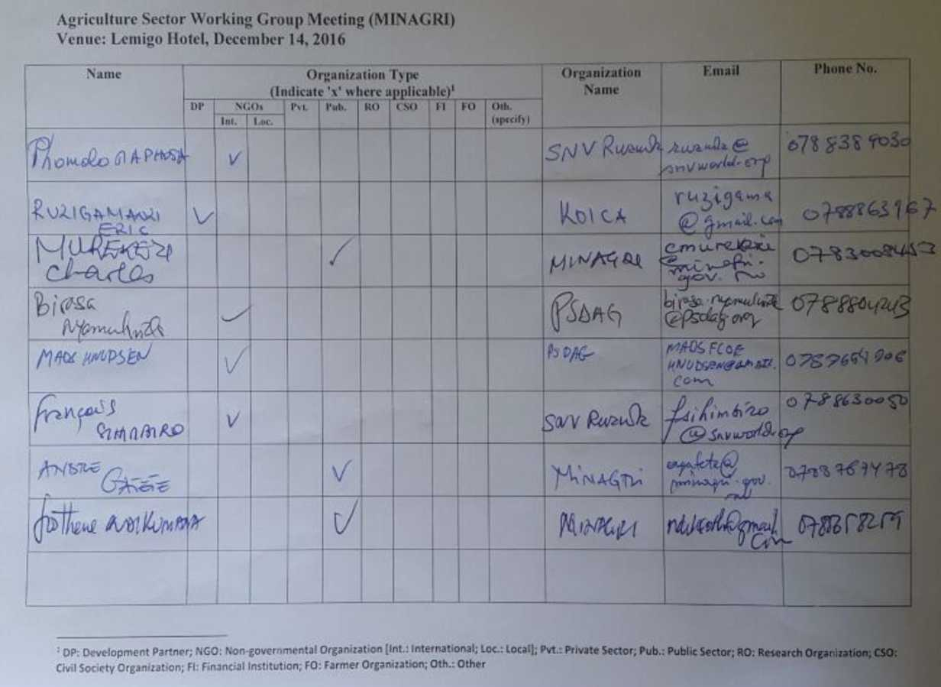

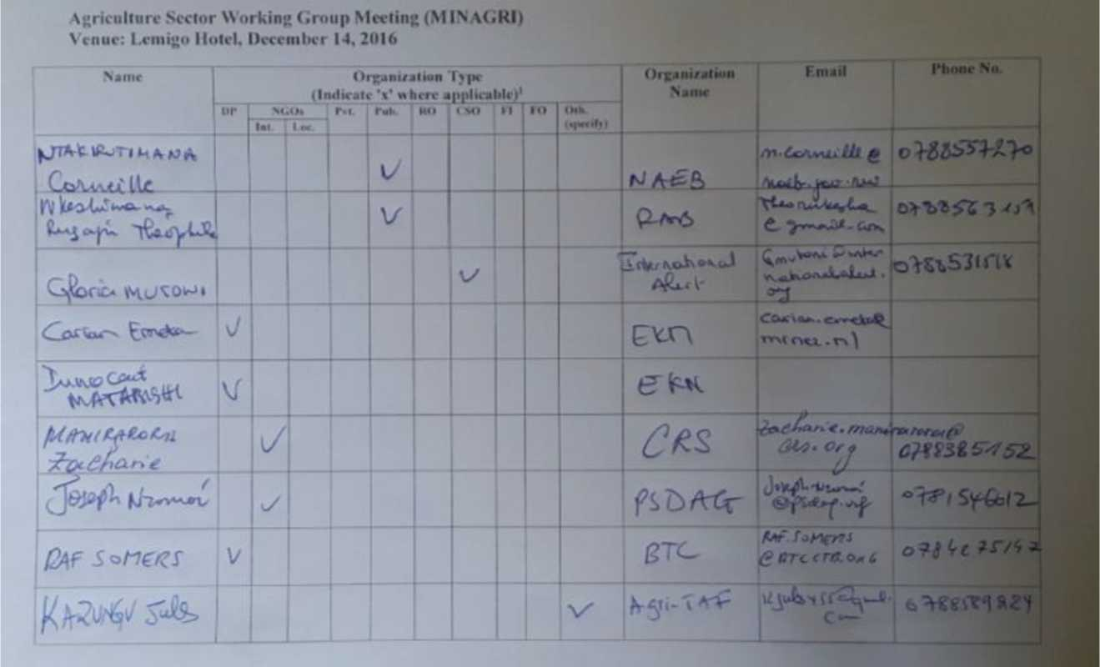

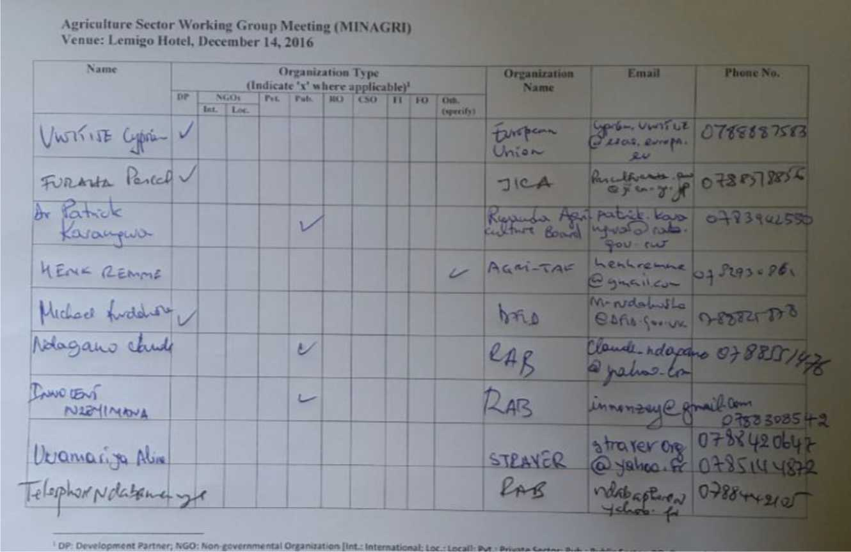

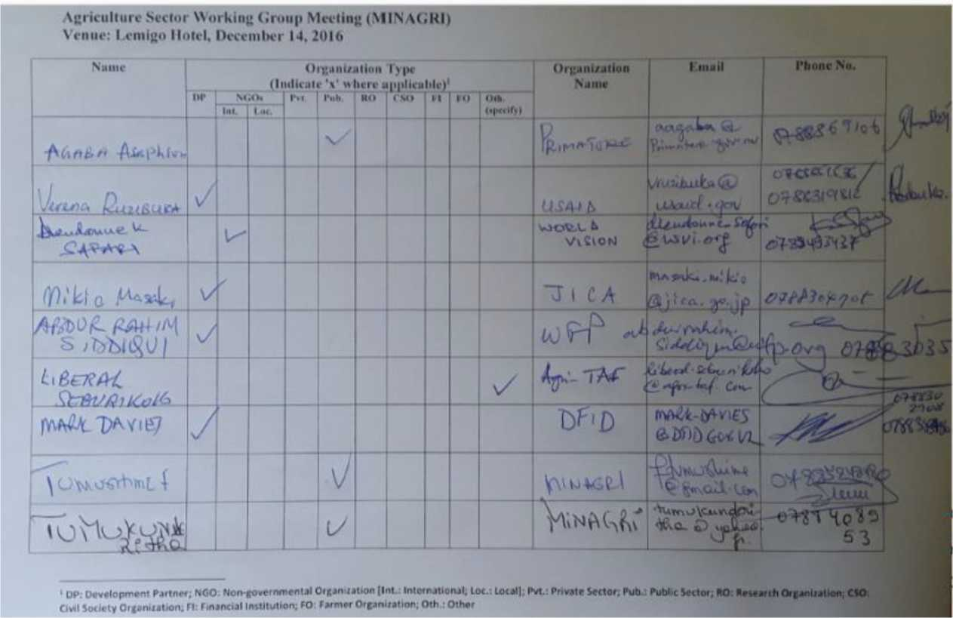

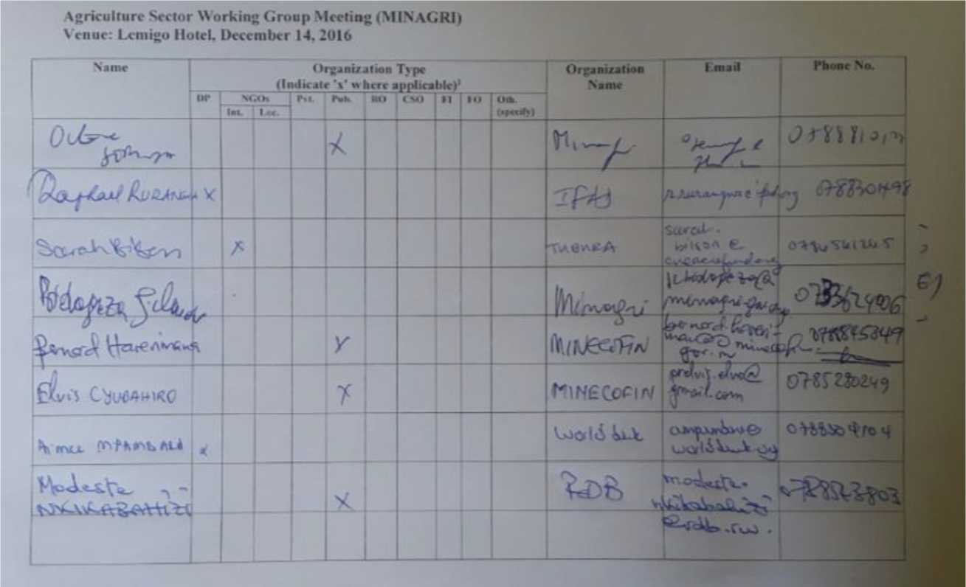

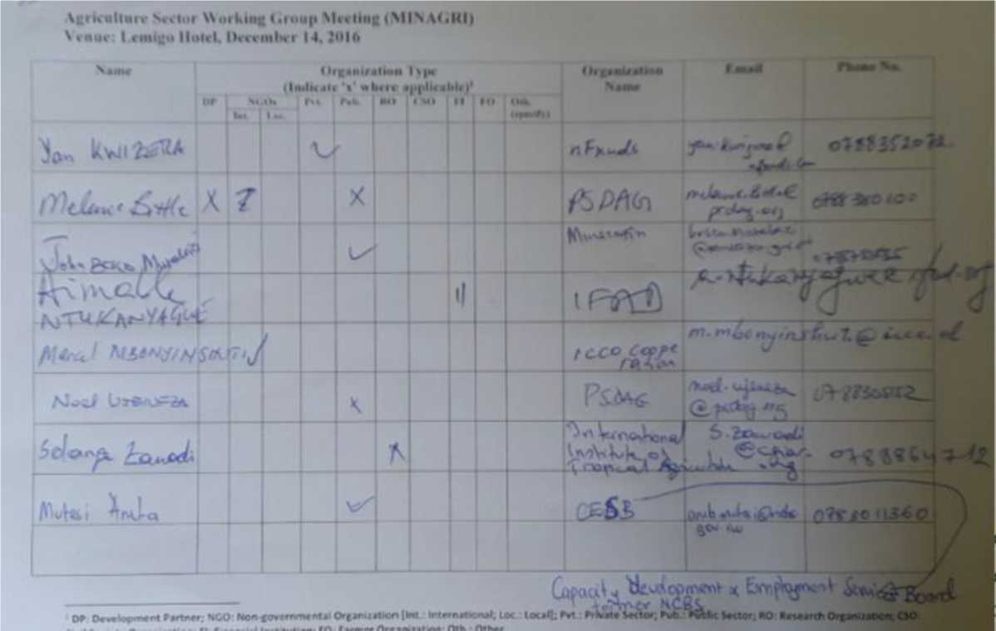

1. **Inter-ministerial consultations**

**LWH/RSSP/RCSP Steering Committee Meeting, 23 December 2016  
ATTENDANCE UST**

|  |  |  |  |  |  |  |
| --- | --- | --- | --- | --- | --- | --- |
| **No** | **Names** | | **Institution** | **email** | **telephone** | **signature** |
| **1** |  | | **KnArs-** | **$'***/?■’ nrft.- fy rr>—» —H** | **Cl** |  |
| **2** |  | |  | Cm **.tin** |  |  |
| **1 1** | **2-i} tA AJA Veclrw t»~** | | **Lit Ai** .sp | **ijutr.Lu tutA..* <u** | **oWjeUuJ^** |  |
| **4** | **TS trcol*w.« N»t*o*«r>»TC** | |  | **li c^»** | **9^Y<12L£_** |  |
| **5** |  | M** 1N/J JR | | **Hl** |  |  |
| **6** | *iLMI* | *ft\*\** | **Al z/VAORI** |  | **ju <66^** |  |
| **7** | **T<X^V) fxMrXi m** | | **ihy turf'** |  |  | |
| **1 1** |  | | **“ JLuI** |  |  |  |
| **9** |  | |  |  |  | L — |
| **10** |  | |  |  |  |  |
| **11** |  | |  |  |  |  |
| **12** |  | |  |  |  |  |
| **L—....**  **13** | **■ ■■ —■** | |  |  |  |  |
| **14** |  | |  |  | **_- _ —i^—** | 1 1 |

1. District/Local level consultations

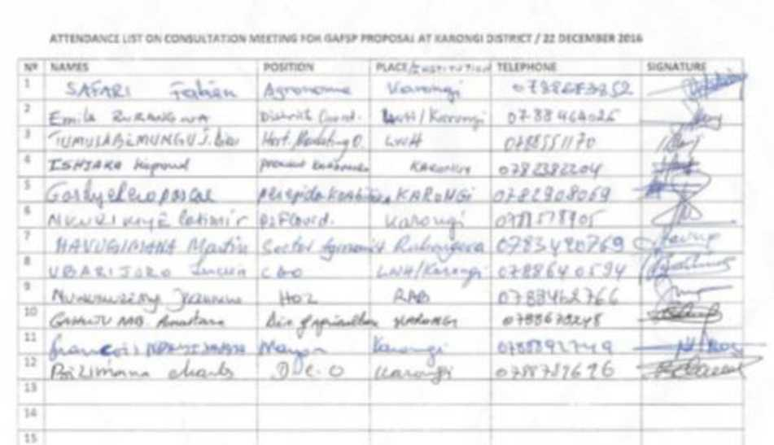

ATTTNOANCT UST CONSULTATION ML I TNG IN NV ANIA

|  |  |  |  |  |  |
| --- | --- | --- | --- | --- | --- |
| **“i?** | **Names** | **InrtNutton** | **AMHion** | **Md'vn** | **S<<na<ur«** |
| **i** | ***to\**** | **P ^CxvaSua ^1A> m** | **■*■ >1 C C O** |  |  |
| **2** |  | **P b ' ^'L—%-** | **fc*!^** | **0-7 K8» ^4^5** | fv sr^i |
| **J** |  | **kilr»l‘ K** | **^rwA-J ikxi^ •** |  |  |
| **\*** |  |  |  | **f7gwy4//??a** |  |
| **S** | **W4^h«A^ >** | ***A4.M*** | ***^^S1U i^*^" \*\**** | ***(i ■*** |  |
| **•** |  | ***/fa&S\eu*** |  |  |  |
| ***1*** |  | **CuVw^** | **x** |  | ***•^‘1*** |
| **a** | **(ft .^oi» M hC«£-HA** | **l^/H-lE-ss?** |  | **C>5rrM4^** |  |
| **a** | **VV«A<w<KlU>C«> UdAiZlirj** |  | (VaI CaZ^> **'^«<Uu^ucLn** | **cmvtsw** | **rfr** |
| **10** |  | **R/z»ifc.X** | **CM** | **c??2.VUJi^** |  |
| **11** |  |  | *VL^* |  |  |
| **12** |  |  | ***O^AH^^A.*** | **9-** |  |
| **11** | **K *hJ^'*** | **f<4r<4-^AN** |  |  |  |
| **14** | **ICTl^AjtaAal^aAAA^** | **Vculiv Yc«iy<A** | **n^pAAwu'ifc** |  |  |
| **15** |  |  |  |  |  |

CONSULTATIVE MEETING FOR LWH PROJECT IMPACT

|  |  |  |  |  |  |
| --- | --- | --- | --- | --- | --- |
|  | SAW | **SeCTOR** | post | **TnfPMCME** |  |
|  |  |  | 1— . „ |  |  |
| 2 |  | Cy-hMi |  |  |  |
| 3 |  |  | 5^-/ |  |  |
| _4 |  |  |  | ***mrr>'*** hi* |  |
| 5i | VA-re. A. a- »'rc^vc***f*** |  | i<^ ^CxSf |  |  |
| ***b*** |  | ***moi-t.*** |  | mb >*»*• «*-» |  |
| ***f*** |  | feASr |  | **A>i7T?Xac** |  |
| 8 | ***fatrfAmMrff*** J&MI,, , |^ | &^NtU ***\*Z*** | !V •/ z^K |  |  |
| 9 |  |  | DM | C?S<Z?f3J3 |  |
| 10 | 77g ?Am f*r>Fyi A>K |  | ***,^V*** | p?y ***til r-f^*** |  |
| 11 | AjzMA'4^ '^aO/x |  |  |  |  |
| 12 |  |  |  |  |  |
| 13  14 | — |  |  |  |  |



CONSULTATIVE MEETING FOR LWH PROJECT IMPACT

|  |  |  |  |  |  |
| --- | --- | --- | --- | --- | --- |
| **IVO** | **SAMI** | **MCTOR** | **POST** | **Ttl£»HO»«** |  |
| 1 | ***f/Sr4^j*'/»n'i4 /-^ dt-^r*** |  |  |  |  |
| 2 | ***H^iKLlue jtan \j,^aiti^*** | **\*7~L'MAA** |  | C X **3 g 1a** X |  |
| 3 | ***a -ri*** | **^VVTyK** |  | e^Tiv^r^- |  |
| 4 | / ’■ - 4fA* |  |  |  |  |
| **5** | ***A^y^X,*** |  | ***S£^*** |  |  |
| 6 | **sJ k^c *to*** Xj |  | **S£^c** | **D6UJc«4%** |  |
| 7 | **^-‘ j 'W-** |  |  | *5 •CT* |  |
| 8 |  |  |  | **0>tia** >r . |  |
| 9 | K\*JV-,’rl3 J»* v ,-««-» |  |  | ^ti2<fiSjxL4L* | J |
| 10 |  |  | **3F *Ire*** | c?7?/A-rO |  |
| 11 | **Aev** | **Au<^r*V** | **A 4r Cz> <10’1^2** | o>»25>5J«>l < |  |
| 12 | **Zh^f' f M** |  |  | o/?Tfz’S3 | lt’W |
| 13 | ***VlILMiftt, U'atL^*** | **^xi^e^et** | **Srl'D** | s^ihjrW |  |
| 14 |  |  |  |  |  |

Attendanc* Met of tho nieettng MM on 22m Docombo* 201k

|  |  |  |  |  |
| --- | --- | --- | --- | --- |
| 1 1 |  | Icwmm—< | **~~JilU~~**P**~~MONI~~** | rx |
|  | r\>\ w /v>*Lx |  | itfW^ |  |
| **1 \*** | *MULi^A^tn* |  |  |  |
|  | ‘H'KTWe <id*a/4 AtM | ^/r | *> OHAMiQt* |  |
|  | *Zul*td* |  | *cA «.U y^i:* |  |
| **4** |  | Pi r *ld^* | t^/c^s c |  |
| **7** | K«w»i T-«~ cU.Ji | SeeUf |  |  |
|  | X ***jru*** | X"// j* * |  |  |
| **•** | ~rV2w»- | a4 | **f*4^ r-MT>7w^** |  |
| **10** |  |  | ***, pf^rfUcyK*** | ***rr>^*** |
|  | 4^^ | f |  |  |
|  | 7)  f v ***wtii. M*** s -- |  |  |  |
| **1)** | Uflorvi CvascAv | <|i | **»a** |  |
| **u** |  | *l'< A^L* | *I h^?CL^i* |  |
| **U** | *Sere*# as ^{..^* | cy j *) nit* |  |  |
| **ik** | ***^st*** 4 v-> 1 |  | **-** |  |
| **12** | Wfa/WtfLM | t««Z. A |  |  |
| **1»** | **1 •** |  | **OfftTM'tlkjW** |  |
| **!•** | **1 A**'1\*\*** | • k<.q |  |  |
| **20** | M)vKAv3c J 6u 1 | *KC^\C»l* 4 *<^,4* | r C?f/?SsC^ |  |

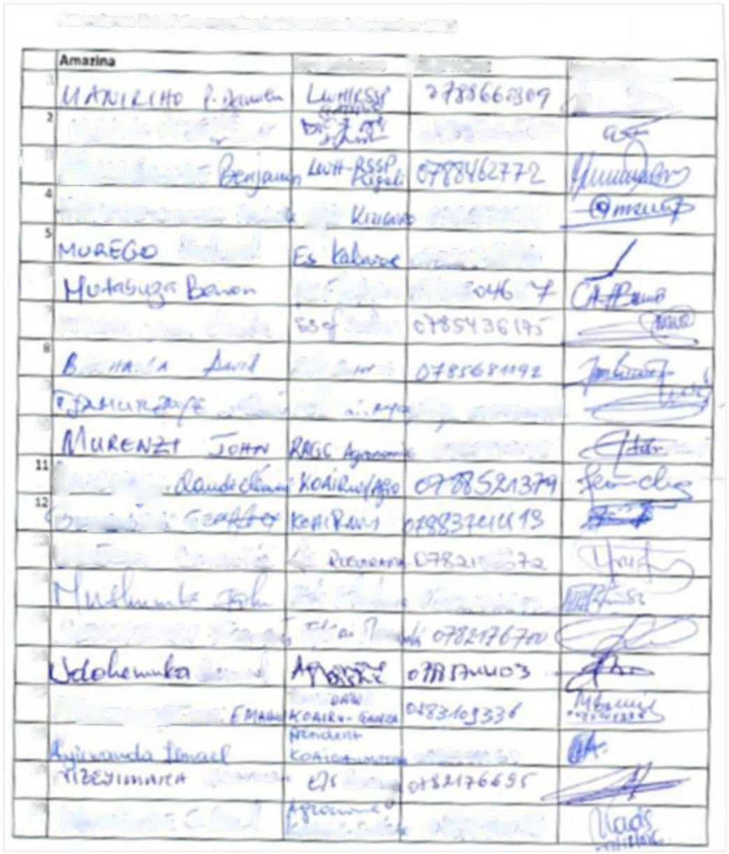

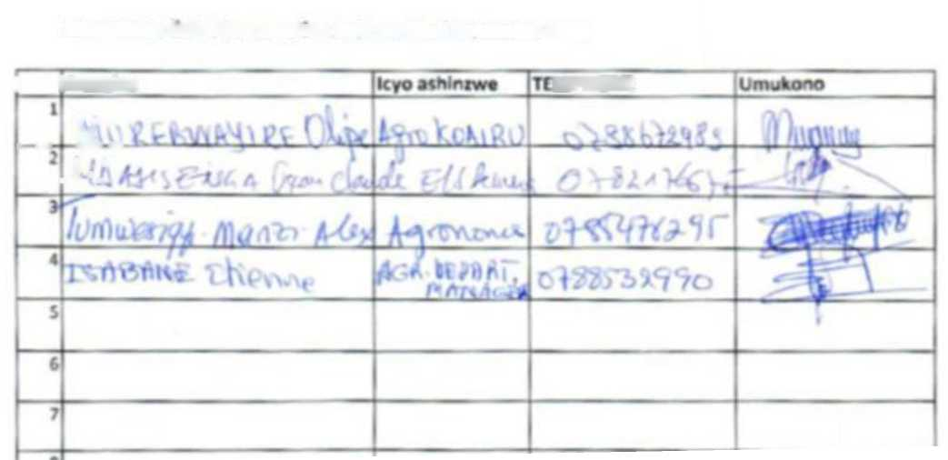

UPHONF

Attendmcc Irjt of the meeting held on 22nd Derembor 201G

I lAnwina

~~Kv~~ i *kJ A <*

Annex 6: List of Government Staff and Government Projects to be involved in the project full design

|  |  |
| --- | --- |
| **Name** | **Function** |
| 1. Semwaga Octave | Director General of Planning, MINAGRI |
| 2. Murekezi Charles | Director General in Charge of Agriculture, MINAGRI |
| 3. Nzeyimana Innocent | Head of Department of Land Husbandry,Irrigation and Mecanisation, RAB |
| 4. Epimaque Nsanzabaganwa | NAEB, Horticulture Division manager |
| 5. Bizimana Jean Claude | Strategic Analyst, MINAGRI |
| 6. Esdras Byringiro | Head of management of information systems Department, SPIU LWH /RSSP |
| 7. Robert Ndabavunnye | Head of engineering and land husbandry, SPIU LWH/RSSP |
| 8. Jean-Claude Karemera | Responsible Rural Finance, SPIU RSSP/LWH |
| 9. Jean Marie Vianney Rusilibana | Head of Commodity Chain Development , SPIU RSSP/LWH |

1. National Institute of Statistics 2015
2. Demographic Health Survey (DHS) 2014/15
3. Data sources include: Govt. of Rwanda, National Institute of Statistics (NISR) GDP 2015/16; Statistics Year Book 2015; Integrated Household Living Conditions Survey (EICV4) 2013/14.
4. 2012/13 - 2017/18
5. 2013/14 - 2017/18
6. Programmed expenditures towards sub programmes of PSTAII and III with a clear nutrition impact (either direct or indirect) have risen steadily over the past years from Rw Fr 15.6 Billion in 2011/12 to 32.1 Billion in 2015/16 - increase of about 105% over the period, in terms of approved allocations. This refers to combined allocation from MINAGRI, MINISANTE and MINALOC. The big share of allocations being made by MINAGRI ranging from RW FR 15.5 billion in 2011/12 to 29.4 billion in 2015/16.
7. A farmer field school (FFS) is an adult education methodology promoted by FAO and other partners since early 1980’s*.* FFS are based on the principles of people centered learning, and were developed as an alternative to the conventional top-down test and verification (T&V) extension approach. It uses innovative and participatory methods to create a learning and empowering environment, in which farmers learn for themselves about particular crop/livestock production problems (including marketing), and ways to address them, through their own observation, discussion and participation in practical learning-by-doing field activities.
8. These included, amongst others, grass strips, soil bunds, bench terraces, afforestation, drainage systems, application of lime and compost
9. MINAGRI SSIT Program 2014; Feasibility study on the farmer-led Small-scale irrigation technologies (SSIT) program